

Database Management Project

Section-2, Final Report

TEAM- DB_Crasher

Group 21

|  |  |
| --- | --- |
| Name | ID |
| Mohammad Azwad Saadat Sarwar | 1910902 |

Table of Contents

CHAPTER-1 INTRODUCTION 4

1. BACKGROUND OF THE ORGANIZATION - IUB 4
2. BACKGROUND OF THE PROJECT - SPMS 4.0: 4
3. OBJECTIVE OF THE PROJECT - SPMS 4.0 4
4. SCOPE OF THE PROJECT: 5

CHAPTER-2 REQUIREMENT ANALYSIS 5

1. RICH PICTURE – EXISTING SYSTEM (SPMS 3.0) 6
2. SIX ELEMENT ANALYSIS – EXISTING SYSTEM (SPMS 3.0) 7
3. PROBLEM ANALYSIS – EXISTING SYSTEM (SPMS 3.0) 25
4. RICH PICTURE – PROPOSED SYSTEM (SPMS 4.0) 27
5. SIX ELEMENT ANALYSIS – PROPOSED SYSTEM (SPMS 4.0) 28

CHAPTER-3 LOGICAL SYSTEM DESIGN 44

1. BUSINESS RULES – SPMS 4.0 44
2. ENTITY RELATIONSHIP DIAGRAM 47
3. ENTITY RELATIONSHIP DIAGRAM TO RELATIONAL SCHEMA 48
4. NORMALIZATION 48

1NF: 51

2NF: 52

3NF: 52

1. DATA DICTIONARY 52

CHAPTER-4 PHYSICAL SYSTEM DESIGN 62

1. INPUT FORMS 62
2. OUTPUT FORMS 72

CHAPTER-5 CONCLUSION 101

1. PROBLEM AND SOLUTION 101

Analysis Phase: 101

Designing Phase: 102

Implementation Phase: 102

Additional Features and Future Development 102

References 102

# CHAPTER-1 INTRODUCTION

## BACKGROUND OF THE ORGANIZATION - IUB:

IUB is a private university in Bangladesh which was established in 1993. It has a current enrollment of around 10 000 at undergraduate and graduate levels [1]. More than 450 highly qualified and highly-skilled faculty members who are exceptionally good at their department of teaching and where at least half of them are PhD degree holders [2]. IUB also has an alumni strength near 14000 people. There are currently 5 academic schools in IUB [1]

1. School of Business & Entrepreneurship
2. School of Engineering, Technology and Sciences
3. School of Environment & Life Sciences
4. School of Liberal Arts & Social Sciences
5. School of Pharmacy and Public Health

## BACKGROUND OF THE PROJECT - SPMS 3.0:

Student Performance Monitoring System (SPMS 3.0) is a framework for Outcome-Based Education (OBE). It evaluates the performance of students, course instructors, schools, departments and programs and helps the Higher Authorities of the education institution to make strategies for improvements.

## OBJECTIVE OF THE PROJECT - SPMS 3.0:

SPMS 3.0 monitors and analyzes the performance of its stakeholders such as Students, Course instructors, Departments, Schools, Programs through the database of assessments such as quizzes, midterm exams, final term exams etc. In order to evaluate the performance of the stakeholders, SPMS 3.0 stores necessary documents and data in the database such as all the exam question papers, answer scripts, course outlines and marks of the exams and assessments with respect to their Course Outcomes (CO), Program Learning Outcomes (PLO) and Program Outcomes (PO) achieved by the students. Hence, students can statistically monitor their own performance. SPMS 3.0 also creates opportunities for Higher Authorities to draw conclusions and make further

improvements by providing them with a wide range of analytical reports based on the performance of students, course instructors, departments, schools, and programs.

## SCOPE OF THE PROJECT:

We have done a complete analysis of the existing system (SPMS 2.0) and identified some issues in the business processes which can cause the process to become slow, inefficient and cause lapses in communication.

The proposed solution to overcome those issues is to create a more improved version of the system called SPMS 3.0 (Student Performance Monitoring System 3.0) which uses a Relational Database Management System (RDBMS) to store, update and retrieve necessary documents such as Course Outlines, Exam Question Papers and Answer Scripts as well as other necessary data required to monitor student performance and produce other OBE (outcome-Based Education) reports.

We have identified all the users of the system (SPMS 3.0), how they would be accessing the necessary data and information and how they would interact with each other etc.

We want to build interfaces for all the users to be able to access their required data and generate, view, and download their desired reports and documents using the system.

We also want to build an interface for the course instructors/faculties to be able to collaborate with each other on developing of course outlines, exam papers, marksheets etc.

# CHAPTER-2 REQUIREMENT ANALYSIS

Requirement Analysis is the process of determining what the database is used for. It involves interviews with stakeholders in order to identify the functionality and system requirements they expect and require from the database, what operations need to be performed and what data they need to process. By doing so, we can get a proper understanding of the stakeholders and how they interact with each other.

## RICH PICTURE – EXISTING SYSTEM (SPMS 2.0):

A rich picture is a way to demonstrate processes in a system which is easier to understand for everyone. It consists of pictures text, symbols and icons which are all used to illustrate graphically the situation. [3] A rich picture helps us to see relationships and connections that we may otherwise miss [3]. It helps identifying one or more themes participants may want to further explore and address. Rich pictures are therefore always used in the pre-analysis phase [3].

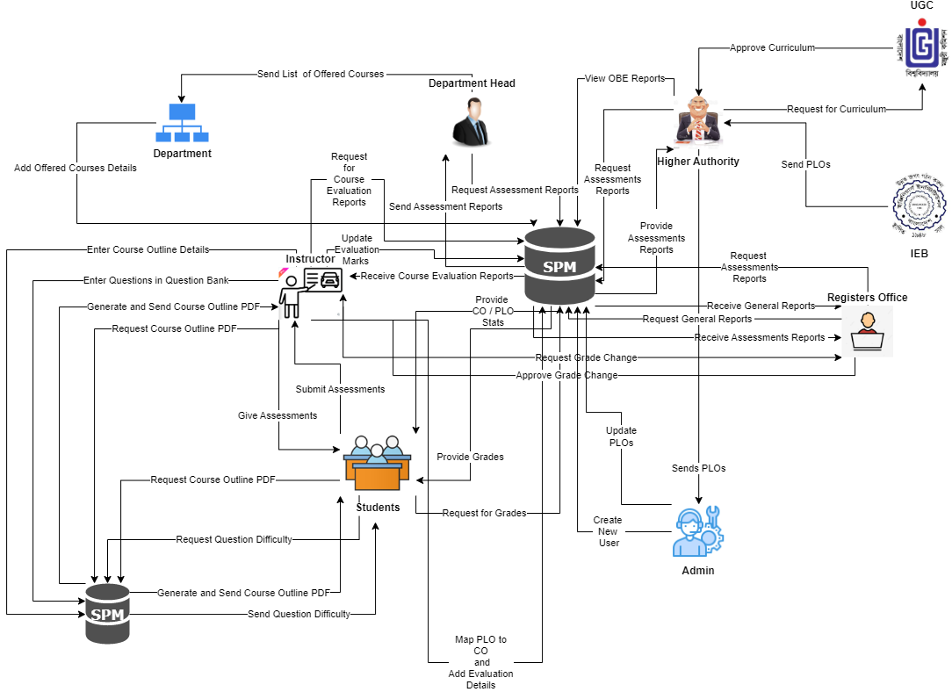

In this rich picture the stakeholders are:

1. UGC
2. IEB
3. Higher Authority (VC, Dean etc)
4. Department Head
5. Department Office
6. SPMSV3.0 Admin (SPMS Manager)
7. Registers Office
8. Faculty
9. Student

The Main Storages are

1. SPMS V3.0
2. Physical Storage (Used by the faculty)

.

## SIX ELEMENT ANALYSIS – EXISTING SYSTEM (SPMS 2.0)

From the rich picture we can see that there are 9 key processes:

1. **Course based student performance trend according to GPA**
2. **Faculty based student performance according to GPA**
3. **Course wise PLO achievement of a student**
4. **Student performance trend under VC/Dean/Head of Department**
5. **Course, Program, department, school CLO-PLO statistics**
6. **Course, student, department school wise expected vs achieved PLO**
7. **Department average of total PLO achieved and attempted students**
8. **Assessments and grading.**
9. **Student Enrollment Statistics VC-wise, Dean-wise, Department Head-wise.**
10. **Creating storing and giving Course Outline.**
11. **Add Questions to the question bank and grading the answer script**
12. **Course based student performance trend according to GPA**
13. **Faculty based student performance according to GPA**
14. **Course wise PLO achievement of a student**
15. **Student performance trend under VC/Dean/Head of Department**
16. **Course, Program, department, school CLO-PLO statistics**
17. **Course, student, department school wise expected vs achieved PLO**
18. **Department average of total PLO achieved and attempted students**
19. **Student Enrollment Statistics VC-wise, Dean-wise, Department Head-wise.**

We can use six element analysis to analyze the impact of six elements in a process here the six elements are

1. Human
2. Non computing Hardware
3. Computing Hardware
4. Software.
5. Database.
6. Network and Communication.

|  |  |  |  |  |  |  |
| --- | --- | --- | --- | --- | --- | --- |
| Process | Human | Non- computing Hardware | Computin g Hardwar  e | Softwar e | Database | Network and Communi  cation |
| **Course based student performanc e trend according to GPA** | **Departmen t Head:**   1. Signs into System using their ID and Password. 2. Input the time period and course ID to be viewed. 3. View student progress through a graph made after analysis and the GPA earned by maximum/ minimum/a verage students.   **Faculty:**   1. Signs into system using their ID and Password. 2. Search for the course that they are teaching using course ID   and time | **Pen and Paper** 1)Can be Used to create Rough assessme nt questions.  2) Used to answer assessme nt questions. | **Comput er/Lapto p**  1) Used to Sign into SPMS2.0  .  **Printer**  1) Used to print hard copy of the progress of current semester ’s students and compare with the progress of the previous semester ’s students who did that course. | **SPMS2. 0**  1)Used to store student Data into the databas e or generat e perform ance analysis graph using data from the databas e. | **SPMS2.0**  **Databas e**  1) All valid data are stored here which can be updated by SPMS2.0 admins. | **Internet** 1)Used to Sign into SPMS2.0 |

|  |  |  |  |  |  |  |
| --- | --- | --- | --- | --- | --- | --- |
|  | period and View the progress of that students of that course.  **Student:**   1. Signs into System using their ID and Password. 2. Search for the course using course ID and View their progress of that course and the GPA they earned.   **Dean/VC :**   1. Signs into system using their ID and Password. 2. Search for the course using course ID and time period and View the progress of the students of that course |  |  |  |  |  |
| **Faculty based student performanc e according to GPA** | **Faculty:**   1. Signs into system using their ID and Password. 2. View the Progress of   the students |  | **Comput er/Lapto p**  1) Used to Sign into SPMS2.0  **Printer** | **SPMS2. 0**  1)Used to store student Data into the databas  e or generat | **SPMS2.0**  **Databas e**  1) All valid data are stored here which  can be | **Internet** 1)Used to Sign into SPMS2.0 |

|  |  |  |  |  |  |  |
| --- | --- | --- | --- | --- | --- | --- |
|  | who are being taught by them.  **Departme nt Head:**   1. Signs into system using their ID and Password. 2. Search for a faculty to be assessed using the Faculty’s name. 3. View the Progress of the students who are being taught under that faculty basing on the GPA earned by the students.   **Dean/VC:**   1. Signs into system using their ID and Password. 2. Search for a faculty to be assessed using the Faculty’s name and Departmen t ID. 3. View the Progress of the   students |  | 1) Used to print hard copy of the progress of students taught by a faculty | e perform ance analysis graph using data from the databas e. | updated by SPMS2.0  admins. |  |

|  |  |  |  |  |  |  |
| --- | --- | --- | --- | --- | --- | --- |
|  | who are being taught under that faculty basing on the GPA earned by the students. |  |  |  |  |  |
| **Course wise PLO**  **achievemen t of a student** | **VC/ Dean:**   1. Signs into system using their ID and Password. 2. Select PLO achieveme nt Tab and search using Course ID 3. View PLOs achieved by the student.   **Departme nt Head:**   1. Signs into system using their ID and Password. 2. Select PLO achieveme nt Tab and search using Course ID 3. View PLOs achieved by the students.   **Faculty:**  1) Signs into system |  | **Comput er/Lapto p**  1) Used to Sign into SPMS2.0  **Printer**  1) Used to print hard copy of a report of students who complete d most the PLO achievem ents  If needed. | **SPMS2. 0**  1)Used to store Data and generat e PLO  automati cally based on the CO  provided  . | **SPMS2.0**  **Databas e**  1) All valid data are stored here which can be updated by SPMS2.0 admins. | **Internet** 1)Used to Sign into SPMS2.0 |

|  |  |  |  |  |  |  |
| --- | --- | --- | --- | --- | --- | --- |
|  | using their ID and Password.   1. Select PLO achieveme nt Tab and search using Course ID 2. View PLOs achieved by the students in a course.   **Student:**   1. Signs into system using their ID and Password. 2. View PLOs they have achieved so far and how many they need to achieve to complete the course. |  |  |  |  |  |
| **Student performanc e trend under VC/Dean/He ad of Department** | **Dean :**   1. Signs into system using their ID and Password. 2. Search for Departmen t Head to be checked using their Name and Departmen t ID. 3. View student progress under them   or them. |  | **Comput er/Lapto p**  1) Used to Sign into SPMS2.0  **Printer**  1) Used to print the hard copy of the progress report if needed. | **SPMS2. 0**  1)Used to store Data into the databas e or generat e perform ance analysis graph using data from the databas e. | **SPMS2.0**  **Databas e**  1) All valid data are stored here which can be updated by SPMS2.0 admins. | **Internet** 1)Used to Sign into SPMS2.0 |

|  |  |  |  |  |  |  |
| --- | --- | --- | --- | --- | --- | --- |
|  | **VC:**   1. Signs into system using their ID and Password. 2. Search for a Dean or Departmen t Head to be checked using their Name and either School ID or Departmen t ID. 3. View student progress under them.   **Departme nt Head:**   1. Signs into system using their ID and Password. 2. View student progress under   them. |  |  |  |  |  |
| **Course, Program, department, school CLO- PLO**  **statistics** | **Dean/VC :**   1. Signs into system using their ID and Password. 2. View CLO-PLO mapped statistics achieved by students.   **Departme nt Head:**  1) Signs into system |  | **Comput er/Lapto p**  1) Used to Sign into SPMS2.0  **Printer**  1) Used to print the hard copy of the progress report if needed. | **SPMS2. 0**  1)Used to store Data into the databas e and generat e CLO- PLO  statistica l data or graphs. | **SPMS2.0**  **Databas e**  1) All valid data are stored here which can be updated by SPMS2.0 admins. | **Internet** 1)Used to Sign into SPMS2.0 |

|  |  |  |  |  |  |  |
| --- | --- | --- | --- | --- | --- | --- |
|  | using their ID and Password.  2) View CLO-PLO mapped statistics achieved by students.  **Faculty:**   1. Signs into system using their ID and Password. 2. View CLO-PLO mapped statistics achieved by students.   **Student:**   1. Signs into system using their ID and Password. 2. View CLO-PLO mapped statistics achieved by them and other students. |  |  |  |  |  |
| **Course, student, department school wise expected vs achieved PLO** | **Dean/VC :**   1. Sign into the system using ID and Password. 2. View the achieved PLO of the students   during time entered |  | **Comput er/Lapto p**  1) Used to Sign into SPMS2.0  **Printer**  1) Used to print  the hard copy of | **SPMS2. 0**  1)Used to store Data into the databas e or generat e perform  ance analysis | **SPMS2.0**  **Databas e**  1) All valid data are stored here which can be updated by | **Internet** 1)Used to Sign into SPMS2.0 |

|  |  |  |  |  |  |  |
| --- | --- | --- | --- | --- | --- | --- |
|  | that has been inputted and compariso n between expected and achieved.  **Departme nt Head:**   1. Sign into the system using ID and Password. 2. View the achieved PLO of the students during time entered that has been inputted and compariso n between expected and achieved.   **Faculty:**   1. Sign into the system using ID and Password. 2. View the achieved PLO of the students during time entered that has been inputted and compariso   n between expected |  | both the previous and current semester ’s achieved PLO to compare. | graph using data from the databas e. | SPMS2.0  admins. |  |

|  |  |  |  |  |  |  |
| --- | --- | --- | --- | --- | --- | --- |
|  | and achieved.  **Student:**   1. Sign into the system using ID and Password. 2. View the achieved PLO of the students during time entered that has been inputted and compariso n between expected and   achieved. |  |  |  |  |  |
| **Department average of total PLO achieved and attempted students** | **Dean/VC :**   1. Sign into the system using ID and Password. 2. Enter the time period of the semester wished to be viewed. 3. View the department al average of total PLO achieved along with the number of students who attempted.   **Departme nt Head:**  1) Sign into the system using ID |  | **Comput er/Lapto p**  1) Used to Sign into SPMS2.0  **Printer**  1) Used to print the hard copy of PLO reports | **SPMS2. 0**  1)Used to store Data into the databas e or generat e perform ance analysis graph using data from the databas e. | **SPMS2.0**  **Databas e**  1) All valid data are stored here which can be updated by SPMS2.0 admins. | **Internet** 1)Used to Sign into SPMS2.0 |

|  |  |  |  |  |  |  |
| --- | --- | --- | --- | --- | --- | --- |
|  | and Password.   1. Enter the time period of the semester wished to be viewed. 2. View the department al average of total PLO achieved along with the number of students who attempted.   **Faculty:**   1. Sign into the system using ID and Password. 2. View the total department al average of the PLO achieved by the students.   **Student:**   1. Sign into the system using ID and Password. 2. View the total department al average of the PLO achieved by the   students |  |  |  |  |  |
| **Assessment s**  **And grading** | **Faculty:**  1) Create Assessme nt with | **Pen and Paper** | **Comput er/Lapto p** | **MS OFFICE**  1)Used to store | **Physical Storage**  1)Used for | **Internet**  1) Used to Sign into Google |

|  |  |  |  |  |  |  |
| --- | --- | --- | --- | --- | --- | --- |
|  | respect to course outline.   1. Give Assessme nt to students. 2. Grade the Answer Script papers returned by students. 3. Store Grades To SPMSV2.0   **Student:**  1) Receive Assessme nt from Faculty.  2)  Complete and Return the Answer Scripts to the respective Faculty.  3)Get Grades From SPMSV2.0  when available | 1. Can be Used to create Rough assessme nt questions. 2. Used to answer assessme nt questions. | 2)To Use MS OFFICE  **Printer**  1) Used to print Hard Copy Of The Assessm ents if required | the Grades in a Spreads heet  2) Used to create the assess ment. | Storing all the answer scripts returned by students | Classroo m if communic ation is required. 2)Used to Sign into SPMS2.0 |
| **Student Enrollment Statistics VC-wise, Dean-wise, Department Head-wise.** | **VC**   1. Sign into the system using ID and Password. 2. Select Student Enrollment Statistics tab and select Year and Semester under that tab 3. View Student Enrollment |  | **Comput er/Lapto p**  1) Used to Sign into SPMS2.0  **Printer**  1) Used to print the hard copy of Student Enrollme nt Statistics If  Needed. | **SPMS2. 0**  1)Used to store Data into the databas e and generat e Student Enrollm ent Statistic s graphs. | **SPMS2.0**  **Databas e**  1) All valid data are stored here which can be updated by SPMS2.0 admins. | **Internet** 1)Used to Sign into SPMS2.0 |

|  |  |  |  |  |  |  |
| --- | --- | --- | --- | --- | --- | --- |
|  | Statistics Of That Year and Semester.  **Dean**   1. Sign into the system using ID and Password. 2. Select Student Enrollment Statistics tab and select Year and Semester under that tab 3. View Student Enrollment Statistics Of That Year and Semester.   **Departme nt Head**   1. Sign into the system using ID and Password. 2. Select Student Enrollment Statistics tab and select Year and Semester under that tab 3. View Student Enrollment Statistics Of That Year and Semester. |  |  |  |  |  |

|  |  |  |  |  |  |  |
| --- | --- | --- | --- | --- | --- | --- |
|  |  |  |  |  |  |  |
| **Preparing and storing Course Outline** | **Faculty:**   1. Request Course Material Of Previous Semester to the Departmen t Office. 2. Create Course Outline 3. Store Course Outline In Physical Storage. 4. Give Course Outline To Students.   **Departme nt Office:**  1) Give Course Material Of Previous Semester  **Students:** 1)Receive Course Outline From Faculty | **Pen and Paper** 1)Used to Create Rough Course Outline Overview | **Comput er/Lapto p**  2)To Use MS OFFICE  **Printer**  1) Used to print Hard Copy Of Course Outline | **MS OFFICE**   1. Used to store the Grades in a Spreads heet 2. Used to create the assess ment. | **Physical Storage** 1)  Course Outlines are Stored Here. | **Internet** 1)Used to Sign into SPMS2.0 |

|  |  |  |  |  |  |  |
| --- | --- | --- | --- | --- | --- | --- |
| Process | Human | Non- compu ting  Hardw are | Computing Hardware | Softwar e | Datab ase | Network and Communi cation |
| **Preparin g storing** | **Faculty:** |  | **Computer/ Laptop** | **SPMS2. 0** | **SPMS 2.0** | **Internet** |

|  |  |  |  |  |  |  |
| --- | --- | --- | --- | --- | --- | --- |
| **and giving Course Outline** | 1. Signs into System using their ID and Password. 2. Select Create Course Outline Tab. 3. Select From the options that they wish to add in their course outline. 4. Press the Create button.   4) Store course outline into system.  **Students:**   1. Signs into System using their ID and Password. 2. Select Course 3)View/Download Course Outline From System. |  | 1) Used to Sign into SPMS2.0  **Printer**  1) Used to print hard copy of course outlines if required. | 1)Used to store Data into the databas e. | **Datab ase**  1) All valid data are stored here which can be updat ed by SPMS 2.0 admin s. | 1)Used to Sign into SPMS2.0 |
| **Add Question s to the question bank and grading the answer script** | **Faculty:**   1. Signs into System using their ID and Password. 2. Select course and choose section’s that has to solve the question. 3. Input the question in the question bank. 4. Press the Assign Button.   4) Grade the answers submitted by the students  **Student:**   1. Signs into System using their ID and Password. 2. Answer the question assigned   by the faculty in the answer bank |  | **Computer/ Laptop**  1) Used to Sign into SPMS2.0  **Printer**  1) Used to print the grades gotten by the whole section | **SPMS2. 0**  1)Used to store Data into the databas e or generat e result graph using data from the databas e. | **SPMS 2.0**  **Datab ase**  1) All valid data are stored here which can be updat ed by SPMS 2.0 admin s. | **Internet** 1)Used to Sign into SPMS2.0 |

|  |  |  |  |  |  |  |
| --- | --- | --- | --- | --- | --- | --- |
|  | 1. Press the Submit button 2. Check grade in SPMS3.0 after faculty is done checking |  |  |  |  |  |
| **Course based student performa nce trend accordin g to GPA** | **Department Head:**   1. Signs into System using their ID and Password. 2. Input the time period and course ID to be viewed. 3. View student progress through a graph made after analysis and the GPA earned by maximum/minimu m/average students.   **Faculty:**   1. Signs into system using their ID and Password. 2. Search for the course that they are teaching using course ID and time period and view the progress of that students of that course.   **Student:**   1. Signs into System using their ID and Password. 2. Search for the course using course ID and View their progress of that course and the GPA they earned.   **Dean/VC :**  1) Signs into  system using their ID and Password. |  | **Computer/ Laptop**  1) Used to Sign into SPMS2.0.  **Printer**  1) Used to print hard copy of the progress of current semester’s students and compare with the progress of the previous semester’s students who did that course. | **SPMS2. 0**  1)Used to store student Data into the databas e or generat e perform ance analysis graph using data from the databas e. | **SPMS 2.0**  **Datab ase**  1) All valid data are stored here which can be updat ed by SPMS 2.0 admin s. | **Internet** 1)Used to Sign into SPMS2.0 |

|  |  |  |  |  |  |  |
| --- | --- | --- | --- | --- | --- | --- |
|  | 2) Search for the course using course ID and time period and View the progress of the students of that course |  |  |  |  |  |
| **Faculty based student performa nce accordin g to GPA** | **Faculty:**   1. Signs into system using their ID and Password. 2. View the Progress of the students who are being taught by them.   **Department Head:**   1. Signs into system using their ID and Password. 2. Search for a faculty to be assessed using the faculty’s name. 3. View the Progress of the students who are being taught under that faculty basing on the GPA earned by the students.   **Dean/VC:**   1. Signs into system using their ID and Password. 2. Search for a faculty to be assessed using the faculty’s name and Department ID. 3. View the Progress of the students who are being taught under that faculty basing on the   GPA earned by the students. |  | **Computer/ Laptop**  1) Used to Sign into SPMS2.0  **Printer**  1) Used to print hard copy of the progress of students taught by a faculty | **SPMS2. 0**  1)Used to store student Data into the databas e or generat e perform ance analysis graph using data from the databas e. | **SPMS 2.0**  **Datab ase**  1) All valid data are stored here which can be updat ed by SPMS 2.0 admin s. | **Internet** 1)Used to Sign into SPMS2.0 |

|  |  |  |  |  |  |  |
| --- | --- | --- | --- | --- | --- | --- |
|  |  |  |  |  |  |  |
| **Course wise PLO**  **achieve ment of a student** | **VC/ Dean:**   1. Signs into system using their ID and Password. 2. Select PLO achievement Tab and search using Course ID 3. View PLOs achieved by the student.   **Department Head:**   1. Signs into system using their ID and Password. 2. Select PLO achievement Tab and search using Course ID 3. View PLOs achieved by the students.   **Faculty:**   1. Signs into system using their ID and Password. 2. Select PLO achievement Tab and search using Course ID 3. View PLOs achieved by the students in a course.   **Student:**   1. Signs into system using their ID and Password. 2. View PLOs they have achieved so far and how many they need to achieve to complete the   course. |  | **Computer/ Laptop**  1) Used to Sign into SPMS2.0  **Printer**  1) Used to print hard copy of a report of students who completed most the PLO achievemen ts  If needed. | **SPMS2. 0**  1)Used to store Data and generat e PLO  automat ically based on the CO  provide d. | **SPMS 2.0**  **Datab ase**  1) All valid data are stored here which can be updat ed by SPMS 2.0 admin s. | **Internet** 1)Used to Sign into SPMS2.0 |
| **Student performa nce**  **trend** | **Dean :**  1) Signs into system using their  ID and Password. |  | **Computer/ Laptop** | **SPMS2. 0**  1)Used to store | **SPMS 2.0**  **Datab ase** | **Internet** 1)Used to Sign into  SPMS2.0 |

|  |  |  |  |  |  |  |
| --- | --- | --- | --- | --- | --- | --- |
| **under VC/Dean/ Head of Departm ent** | 1. Search for Department Head to be checked using their Name and Department ID. 2. View student progress under them or them.   **VC:**   1. Signs into system using their ID and Password. 2. Search for a Dean or Department Head to be checked using their Name and either School ID or Department ID. 3. View student progress under them.   **Department Head:**   1. Signs into system using their ID and Password. 2. View student progress under   them. |  | 1) Used to Sign into SPMS2.0  **Printer**  1) Used to print the hard copy of the progress report if needed | Data into the databas e or generat e perform ance analysis graph using data from the databas e. | 1) All valid data are stored here which can be updat ed by SPMS 2.0 admin s. |  |
| **Course, Program, departm ent, school CLO- PLO**  **statistics** | **Dean/VC :**   1. Signs into system using their ID and Password. 2. View CLO-PLO mapped statistics achieved by students.   **Department Head:**   1. Signs into system using their ID and Password. 2. View CLO-PLO mapped statistics achieved by students.   **Faculty:** |  | **Computer/ Laptop**  1) Used to Sign into SPMS2.0  **Printer**  1) Used to print the hard copy of the progress report if needed | **SPMS2. 0**  1)Used to store Data into the databas e and generat e CLO- PLO  statistic al data or graphs. | **SPMS 2.0**  **Datab ase**  1) All valid data are stored here which can be updat ed by SPMS 2.0 admin s. | **Internet** 1)Used to Sign into SPMS2.0 |

|  |  |  |  |  |  |  |
| --- | --- | --- | --- | --- | --- | --- |
|  | 1. Signs into system using their ID and Password. 2. View CLO-PLO mapped statistics achieved by students.   **Student:**   1. Signs into system using their ID and Password. 2. View CLO-PLO mapped statistics achieved by them and other students. |  |  |  |  |  |
| **Course, student, departm ent school wise expected vs achieved PLO** | **Dean/VC :**   1. Sign into the system using ID and Password. 2. View the achieved PLO of the students during time entered that has been inputted and comparison between expected and achieved.   **Department Head:**   1. Sign into the system using ID and Password. 2. View the achieved PLO of the students during time entered that has been inputted and comparison between expected and achieved.   **Faculty:**  1) Sign into the  system using ID and Password. |  | **Computer/ Laptop**  1) Used to Sign into SPMS2.0  **Printer**  1) Used to print the hard copy of both the previous and current semester’s achieved PLO to compare. | **SPMS2. 0**  1)Used to store Data into the databas e or generat e perform ance analysis graph using data from the databas e. | **SPMS 2.0**  **Datab ase**  1) All valid data are stored here which can be updat ed by SPMS 2.0 admin s. | **Internet** 1)Used to Sign into SPMS2.0 |

|  |  |  |  |  |  |  |
| --- | --- | --- | --- | --- | --- | --- |
|  | 2) View the achieved PLO of the students during time entered that has been inputted and comparison between expected and achieved.  **Student:**   1. Sign into the system using ID and Password. 2. View the achieved PLO of the students during time entered that has been inputted and comparison   between expected and achieved. |  |  |  |  |  |
| **Departm ent average of total PLO**  **achieved and attempte d students** | **Dean/VC :**   1. Sign into the system using ID and Password. 2. Enter the time period of the semester wished to be viewed. 3. View the departmental average of total PLO achieved along with the number of students who attempted.   **Department Head:**   1. Sign into the system using ID and Password. 2. Enter the time period of the semester wished to be viewed. 3. View the departmental average of total PLO achieved   along with the number of |  | **Computer/ Laptop**  1) Used to Sign into SPMS2.0  **Printer**  1) Used to print the hard copy of  PLO reports | **SPMS2. 0**  1)Used to store Data into the databas e or generat e perform ance analysis graph using data from the databas e. | **SPMS 2.0**  **Datab ase**  1) All valid data are stored here which can be updat ed by SPMS 2.0 admin s. | **Internet** 1)Used to Sign into SPMS2.0 |

|  |  |  |  |  |  |  |
| --- | --- | --- | --- | --- | --- | --- |
|  | students who attempted.  **Faculty:**   1. Sign into the system using ID and Password. 2. View the total departmental average of the PLO achieved by the students.   **Student:**   1. Sign into the system using ID and Password. 2. View the total departmental average of the PLO achieved by the students |  |  |  |  |  |
| **Student Enrollme nt Statistics VC-wise, Dean- wise, Departm ent**  **Head- wise.** | **VC**   1. Sign into the system using ID and Password. 2. Select Student Enrollment Statistics tab and select Year and Semester under that tab 3. View Student Enrollment Statistics Of That Year and Semester.   **Dean**   1. Sign into the system using ID and Password. 2. Select Student Enrollment Statistics tab and select Year and Semester under that tab 3. View Student   Enrollment Statistics Of That |  | **Computer/ Laptop**  1) Used to Sign into SPMS2.0  **Printer**  1) Used to print the hard copy of  Student Enrollment Statistics If Needed. | SPMS2. 0  1)Used to store Data into the databas e and generat e Student Enrollm ent Statistic s graphs. | **SPMS 2.0**  **Datab ase**  1) All valid data are stored here which can be updat ed by SPMS 2.0 admin s. | **Internet** 1)Used to Sign into SPMS2.0 |

|  |  |  |  |  |  |  |
| --- | --- | --- | --- | --- | --- | --- |
|  | Year and Semester.  **Department Head**   1. Sign into the system using ID and Password. 2. Select Student Enrollment Statistics tab and select Year and Semester under that tab 3. View Student Enrollment Statistics Of That Year and   Semester. |  |  |  |  |  |

## 

## PROBLEM ANALYSIS – EXISTING SYSTEM (SPMS 2.0):

The problems in SPMS2.0 were analyzed, and the proposed solution are given in the following.

|  |  |  |  |  |
| --- | --- | --- | --- | --- |
| **Process Name** | **Stake Holders** | **Concerns(Problems)** | **Analysis(Reason of The Problem)** | **Proposed Solution** |
| **CO Analysis by grade** | **Faculty: Student:** | 1. Cannot view CO earned per course by students according to their grades. | 1) No input forum created that takes grades as input and displays a chart to analyze a student’s CO achieved according to the grade received. | There is an input forum that takes course details, student details and grade into account and generates a spider chart to display the outcome. |

## RICH PICTURE – PROPOSED SYSTEM (SPMS 3.0):

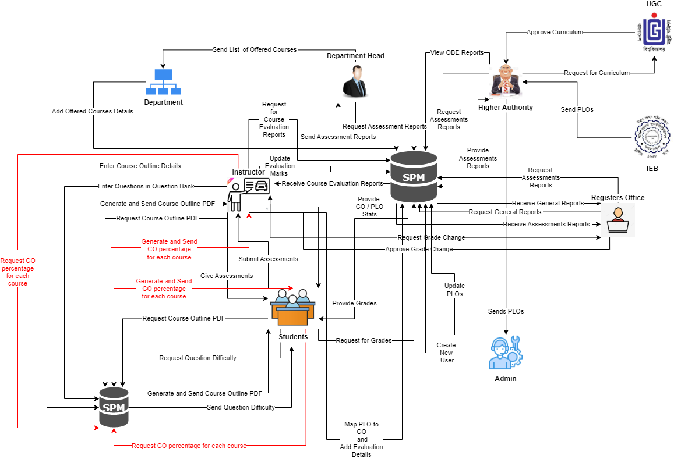

In this rich picture the stakeholders are:

1. UGC
2. IEB
3. Higher Authority (VC, Dean etc)
4. Department Head
5. Department Office
6. SPMSV4.0 Admin (SPMS Manager)
7. Registers Office
8. Faculty
9. Student

The Main Storage is

1) SPMS V4.0

## SIX ELEMENT ANALYSIS – PROPOSED SYSTEM (SPMS 3.0):

From the rich picture we can see that there are 2 key processes:

1. **Calculate CO percentage per course as per grade.**
2. **Generate spider chart according to percentage calculated.**

We can use six element analysis to analyze the impact of six elements in a process here the six elements are

1. Human
2. Non computing Hardware
3. Computing Hardware
4. Software.
5. Database.
6. Network and Communication.

|  |  |  |  |  |  |  |
| --- | --- | --- | --- | --- | --- | --- |
| CO  achieveme nt per course | Student:   1. Logs   into the system  using  Student- ID  and  password.   1. Selects CO   achieveme nt per course   1. View CO   Achievem ent per course. |  | Computer/ Laptop  a)User will need a computer to access SPMS  Printer a)Used to  print out  the report if need be.  Networkin g Devices | SPMS  a) A CO achievement will be  generated by the software. | SPMS  Database  a) Here, the performance will be stored and updated. | Internet  a) To login into and  access the SPMS it is used. |
|  | Admin:   1. Logs   into the System  using user-ID  and password.   1. Selects CO   achieveme nt   1. View CO   Achievem ent per course.  Faculty:   1. Logs into   the System  using  Faculty- ID and  password.   1. Selects |  | (Router,  Switch,  Bridge, Hub):  a)Used to access the Internet. |  |  |  |
|  | CO  Achievem ent.  c) View CO  Achievem ent per course. |  |  |  |  |  |

# CHAPTER-3 LOGICAL SYSTEM DESIGN

## BUSINESS RULES – SPMS 3.0:

1. A student must have one department. A STUDENT has StudentID, FirstName, LastName, dateOfBirth, gender, email, phone, address, departmentID, programID, enrollmentYear,enrollmentSemester,password. A department must have one or many Students.
2. Student may perform many registrations. A REGISTRATION includes RegistrationID, sectionID, studentID. A registration must be performed by at least one student.
3. A section mandatorily have many registrations. A registration has at least one section. A section includes sectionID, sectionNum, courseID, facultyID, year.
4. A registration may belong to many EVALUATIONS. An evaluation mandatorily belongs to one registration. An EVALUATION contains evaluationID, examID, registrationID,totalMarks.
5. A CO must map with one PLO. A PLO’s must map with one or many CO’s. PLO includes ploID, ploNum, programID.
6. A PLO must contain one program. A program contains one or many PLO’s. A PROGRAM has programID, programName, departmentID. A program must contain one or many courses. A Course must contain one course.
7. A program must belong to one department. A department must belong to one or many programs. A DEPARTMENT contains departmentID, departmentName, schoolID.
8. A department must contain one school. A SCHOOL must contain one or many departments. A school includes schoolID, schoolName.
9. An employee has four sub-type( Dean, Department Head, Faculty, VC). An EMPLOYEE includes employeeID,password, firstName, lastName.
10. A school must be run by exactly one. A dean must run exactly one school. A DEAN has schoolID, startDate, endDate.
11. A Department must be run by exactly one Department head. A department head must manage exactly one department. A DEPARTMENTHEAD includes departmentID, startDate, endDate.
12. A Faculty must have exactly one Department. A department must have one or many Faculties. A FACULTY includes departmentID, rank, joinDate. A faculty may teach many sections. A section must be taught by exactly one faculty.
13. A course outline belongs to exactly one section. A section must have exactly one course outline. A COURSE_OUTLINE includes courseOutlineID ,sectionID

,contactHours ,courseDescription ,objective ,content ,refMaterials ,courseType

,courseTitle ,prerequisiteCode ,creditValue.

1. A Course outline must have exactly one CLO Matrix. A CLO matrix belongs to exactly one course outline. A CLO_MATRIX includes clo_MatID, cloNum, coDescription, ploAssessed, correlation, courseOutlineID , c ,p ,a ,s.
2. A Lesson Plan Strategy must have exactly one Evaluation strategy. An Evaluation strategy must have exactly one Lesson Plan Strategy .A LESSON_PLAN_STRATEGY includes lPSID ,week ,topic ,learningStrategy , assessmentStrategy, correspondingClo, courseOutlineID.
3. An exam has exactly one evaluation. An Evaluation for an exam is done exactly once. An exam belongs to exactly one section. An EXAM includes examID, examName, sectionID. A section must have one or many exams.
4. An exam must have one or many questions. Every question must belong to exactly one exam. A QUESTION includes questionID , questionDetails , marksPerQuestion , questionNum , difficutltyLevel , examID , coNum. A Question is answered exactly once. An answer has exactly one question.
5. A PO belongs to exactly one program A program must have one or many PO.PO includes poID , poNum , programID. A PO must belong to one or many CO. A CO must have exactly one PO.
6. A student course performance evaluation is done for registration exactly once. A registration has student course performance evaluation done exactly once. A registration has exactly one evaluation. An Evaluation has exactly one registration.

## ENTITY RELATIONSHIP DIAGRAM:

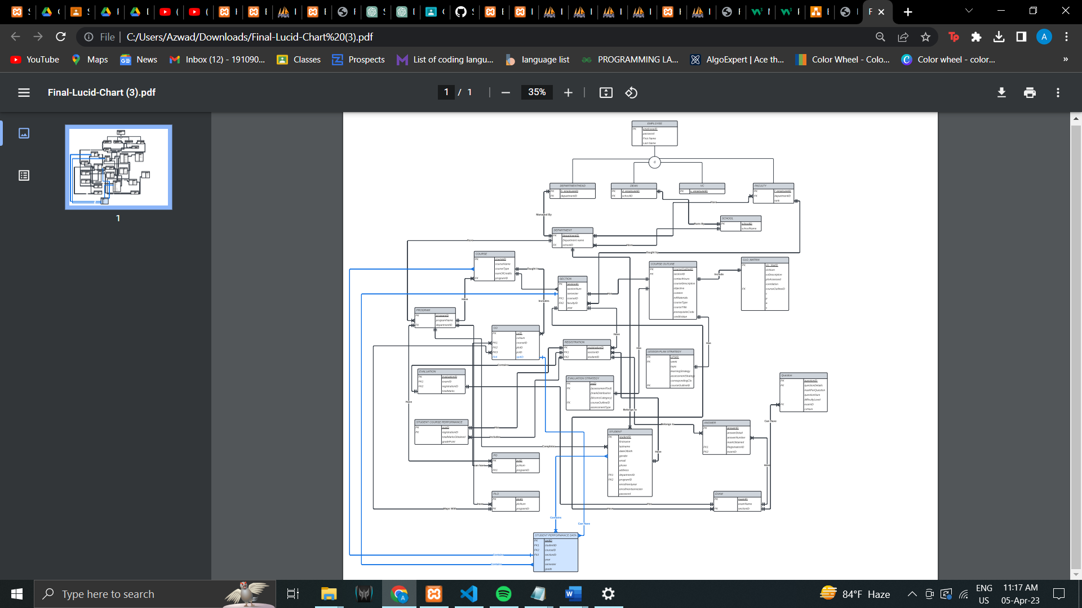

## ENTITY RELATIONSHIP DIAGRAM TO RELATIONAL SCHEMA:

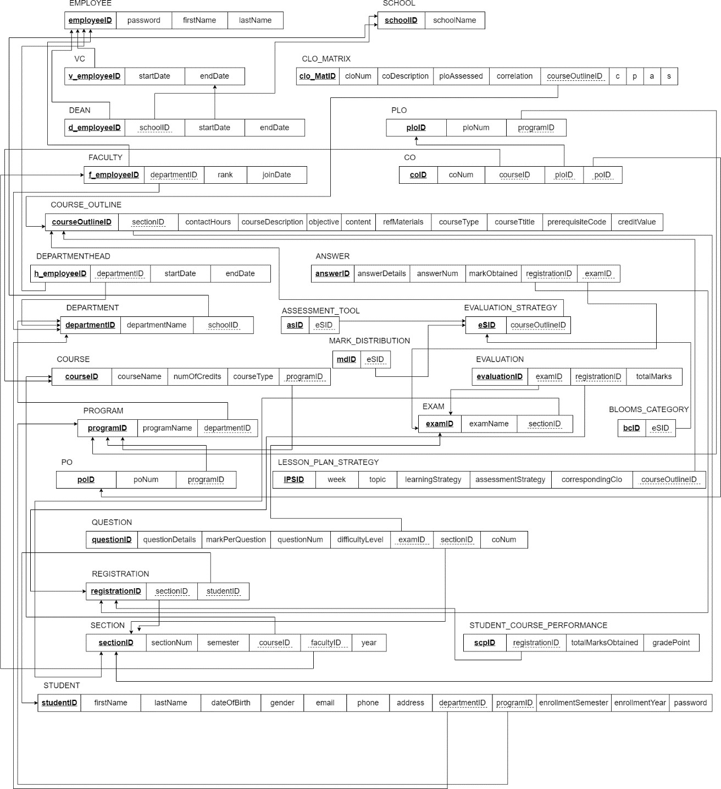

## NORMALIZATION:

|  |  |  |  |  |
| --- | --- | --- | --- | --- |
| EMPLOYEE (i) |  | employeeID | i1 |  |
| password | i2 |  |
| firstName | i3 |  |
| lastName | i4 |  |
| VC (v) |  | v_employeeID | v1 |  |

|  |  |  |  |  |
| --- | --- | --- | --- | --- |
|  |  | startDate | v2 |  |
| endDate | v3 |  |
| DEAN (w) |  | d_employeeID | w1 |  |
| schoolID | h1 |  |
| startDate | w2 |  |
| endDate | w3 |  |
| FACULTY (F) |  | f_employeeID | f1 |  |
| departmentID | d1 |  |
| rank | f2 |  |
| joinDate | f3 |  |
| COURSE_OUTLINE (c) |  | courseOutlineID | c1 |  |
| sectionID | y1 |  |
| contactHours | c2 |  |
| courseDescription | c3 |  |
| objective | c4 |  |
| content | c5 |  |
| refMaterials | c6 |  |
| courseType | c7 |  |
| courseTitle | c8 |  |
| prerequsiteCode | c9 |  |
| creditValue | c10 |  |
| DEPARTMENTHEAD (k) |  | h_employeeID | k1 |  |
| departmentID | d1 |  |
| startDate | k2 |  |
| endDate | k3 |  |
| DEPARTMENT (d) |  | departmentID | d1 |  |
| departmentName | d2 |  |
| schoolID | h1 |  |
| COURSE (u) |  | courseID | u1 |  |
| courseName | u2 |  |
| numOfCredits | u3 |  |
| courseType | u4 |  |
| programID | r1 |  |
| PROGRAM (r) |  | programID | r1 |  |
| programName | r2 |  |
| departmentID | d1 |  |
| PO (x) |  | poID | x1 |  |
| poNum | x2 |  |
| programID | r1 |  |
| QUESTION (q) |  | questionID | q1 |  |
| questionDetails | q2 |  |
| markPerQuestion | q3 |  |
| questionNum | q4 |  |
| difficultyLevel | q5 |  |
| examID | e1 |  |
| courseID | u1 |  |
| coNum | q6 |  |
| REGISTRATION (g) |  | registrationID | g1 |  |
| sectionID | y1 |  |
| studentID | s1 |  |
| SECTION (y) |  | sectionID | y1 |  |
| sectionNum | y2 |  |

|  |  |  |  |  |  |
| --- | --- | --- | --- | --- | --- |
|  |  | semester | y3 | |  |
| courseID | u1 | |  |
| facultyID | f1 | |  |
| year | y4 | |  |
| STUDENT (s) |  | studentID | | s1 |  |
| firstName | | s2 |  |
| lastName | | s3 |  |
| dateOfBirth | | s4 |  |
| gender | | s5 |  |
| email | | s6 |  |
| phone | | s7 |  |
| address | | s8 |  |
| departmentID | | d1 |  |
| programID | | r1 |  |
| enrollmentSemester | | s9 |  |
| enrollmentYear | | s10 |  |
| password | | s11 |  |
| SCHOOL (h) |  | schoolID | h1 | |  |
| schoolName | h2 | |  |
| CLO_MATRIX (m) |  | clo_MatID | m1 | |  |
| cloNum | m2 | |  |
| coDescription | m3 | |  |
| ploAssessed | m4 | |  |
| correlation | m5 | |  |
| courseOutlineID | c1 | |  |
| c | m6 | |  |
| p | m7 | |  |
| a | m8 | |  |
| s | m9 | |  |
| PLO (p) |  | ploID | p1 | |  |
| ploNum | p2 | |  |
| programID | r1 | |  |
| CO (o) |  | coID | o1 | |  |
| coNum | o2 | |  |
| courseID | u1 | |  |
| ploID | p1 | |  |
| poID | x1 | |  |
|  | spdID | aa1 | |  |
| ANSWER (a) |  | answerID | a1 | |  |
| answerDetails | a2 | |  |
| answerNum | a3 | |  |
| markObtained | a4 | |  |
| registrationID | g1 | |  |
| examID | e1 | |  |
| EVALUATION_STRATEGY (t) |  | eSID | t1 | |  |
| assessmentTool | t2 | |  |
| markDistribution | t3 | |  |
| bloomsCategory | t4 | |  |
| courseOutlineID | c1 | |  |
| EVALUTION (n) |  | evaluationID | n1 | |  |
| examID | e1 | |  |
| registrationID | g1 | |  |
| totalMarks | n2 | |  |

|  |  |  |  |  |  |
| --- | --- | --- | --- | --- | --- |
| EXAM (e) |  | examID | e1 | |  |
| examName | e2 | |  |
| sectionID | y1 | |  |
| LESSON_PLAN_STRATEGY (l) |  | IPSID | | l1 |  |
| week | | l2 |  |
| topic | | l3 |  |
| learningStrategy | | l4 |  |
| assessmentStrategy | | l5 |  |
| correspondingClo | | l6 |  |
| courseOutlineID | | c1 |  |
| STUDENT_COURSE_PERFORMANCE (z) |  | scpID | | z1 |  |
| registrationID | | g1 |  |
| totalMarksObtained | | z2 |  |
| gradePoint | | z3 |  |

|  |  |  |  |  |
| --- | --- | --- | --- | --- |
| STUDENT PERFORMANCE DATA(aa) |  | spdID | aa1 |  |
|  | studentID | s1 |  |
|  | courseID | u1 |  |
|  | sectionID | y1 |  |
|  | year | aa2 |  |
|  | semester | aa3 |  |
|  | grade | aa4 |  |

## E.DATA DICTIONARY:

VC_T

|  |  |  |  |  |
| --- | --- | --- | --- | --- |
| Name |  | Data Type | Size | Remark |
| v_employeeID |  | INTEGER | 11 | This is the foreign key from the Employee table. E.g: “4250” |
| startDate |  | DATE |  | This is starting date for the VC. E.g: “01-03-  2020” |
| endDate |  | DATE |  | This is the date VC retire from his post. E.g:  “01-03-2024” |

STUDENT_T

|  |  |  |  |
| --- | --- | --- | --- |
| Name | Data Type | Size | Remark |
| studentID | INTEGER | 11 | This is the primary key for the Student table. E.g: “1921834”. |
| firstName | VARCHAR | 30 | This is the first name of the student. E.g: “Rakibul”. |
| lastName | VARCHAR | 30 | This is the last name of the student. E.g: “Hasan”. |
| dateOfBirth | DATE |  | This is the birth date of the student. E.g: “21- 12-1996”. |
| gender | VARCHAR | 6 | This is the gender of the student.  E.g: “Female”. |
| email | VARCHAR | 30 | This is the email of the student.  E.g:  “[1921834@iub.edu.bd](mailto:1921834@iub.edu.bd)” |
| phone | VARCHAR | 11 | This is the phone of the student.  E.g: “01XXXXXXXXX”. |
| address | VARCHAR | 50 | This is the address of the student. E.g: “House 1,Road 4,Block D, Bashundhara RA |
| departmentID | VARCHAR | 3 | This is the foreign key from the  Department table. E.g: “CSE” |
| programID | INTEGER | 11 | This is the foreign key from the Program table.  E.g: “1” |
| enrollmentSemester | VARCHAR | 10 | This is the enrollment  semester of the student. |
| enrollmentYear | VARCHAR | 4 | This is enrollment year of the student. |

STUDENT_COURSE_PERFORMANCE_T

|  |  |  |  |
| --- | --- | --- | --- |
| Name | Data Type | Size | Remark |
| scpID | INTEGER | 11 | This is the primary key for this table |
| registrationID | INTEGER | 11 | This is the foreign  key from registration table |
| totalMarksObtained | INTEGER | 11 | This is the total marks obtained by the student |
| gradePoint | FLOAT |  | This is the grade point achieved by  the student |

SECTION_T

|  |  |  |  |
| --- | --- | --- | --- |
| Name | Data Type | Size | Remark |
| sectionID | INTEGER | 11 | This is the Primary Key for Section.  E.g: “1” |
| sectionNum | INTEGER | 11 | This is the section number.  E.g: “1” |
| semester | VARCHAR | 6 | This is the semester of the section. E.g: “Summer” |
| courseID | VARCHAR | 6 | This is the foreign key from the Course table.  E.g: “CSE101” |
| facultyID | INTEGER | 11 | This is the foreign key from Faculty  table. E.g: “1801” |
| year | YEAR | 4 | This is the year this section of this course was taken by this specific  faculty |

SCHOOL_T

|  |  |  |  |
| --- | --- | --- | --- |
| Name | Data Type | Size | Remark |
| schoolID | VARCHAR | 5 | This is the primary key of School. E.g:  “SETS” |
| schoolName | VARCHAR | 50 | This is the name of the School.  E.g: “School of Engineering, |

|  |  |  |  |
| --- | --- | --- | --- |
|  |  |  | Technology & Science”. |

REGISTRATION_T

|  |  |  |  |
| --- | --- | --- | --- |
| Name | Data Type | Size | Remark |
| registrationID | INTEGER | 11 | This is the Primary Key for Registration. E.g: “0101010101” |
| sectionID | INTEGER | 11 | This is the foreign key from section  table |
| studentID | INTEGER | 11 | This is the foreign  key from student table |

QUESTION_T

|  |  |  |  |
| --- | --- | --- | --- |
| Name | Data Type | Size | Remark |
| questionID | INTEGER | 11 | This is the primary key of this table |
| questionDetails | MEDIUMTEXT |  | This is the question |
| markPerQuestion | INTEGER | 11 | This is the mark  each question contains |
| questionNum | INTEGER | 11 | This is the number of the question |
| difficultyLevel | INTEGER | 11 | This is the difficulty level of the question |
| examID | VARCHAR | 20 | This is the foreign key from exam  table |
| courseID | VARCHAR | 6 | This is the foreign  key from course table |
| coNum | INTEGER | 11 | This is the CO number of the  question |

PROGRAM_T

|  |  |  |  |
| --- | --- | --- | --- |
| Name | Data Type | Size | Remark |
| programID | INTEGER | 11 | This is the primary  key for a program. E.g: “1” |
| programName | VARCHAR | 50 | This is the name of the program. E.g: “Bachelor of  Science” |
| departmentID | VARCHAR | 3 | This is the foreign  key from the Department table. |

|  |  |  |  |
| --- | --- | --- | --- |
|  |  |  | E.g: “CSE” |

PO_T

|  |  |  |  |
| --- | --- | --- | --- |
| Name | Data Type | Size | Remark |
| poID | VARCHAR | 5 | This is the primary key for Program Outcome.  E.g: “PO1” |
| poNum | INTEGER | 11 | This is the PO number. E.g: “1” |
| programID | INTEGER | 11 | This is a foreign key from Program table.  E.g: “1” |

PLO_T

|  |  |  |  |
| --- | --- | --- | --- |
| Name | Data Type | Size | Remark |
| ploID | INTEGER | 11 | This is the primary key for Program Learning Outcome. E.g: “PLO1” |
| ploNum | INTEGER | 11 | This is the PLO number. E.g: “1” |
| programID | INTEGER | 11 | This is a foreign key  from Program table. E.g: “1” |

LESSON_PLAN_STRATEGY_T

|  |  |  |  |
| --- | --- | --- | --- |
| Name | Data Type | Size | Remark |
| lpsID | INTEGER | 11 | This is the primary key of the table |
| week | INTEGER | 11 | This is the week number |
| topic | MEDIUMTEXT |  | This is the topic name |
| learningStrategy | MEDIUMTEXT |  | This is the lesson plan strategy of  that topic |
| assessmentStrategy | VARCHAR | 10 | This is the assessment  strategy of that topic |
| courseOutlineID | INTEGER | 11 | This is the foreign key from course  outline table |

FACULTY_T

|  |  |  |  |
| --- | --- | --- | --- |
| Name | Data Type | Size | Remark |

|  |  |  |  |
| --- | --- | --- | --- |
| f_employeeID | INTEGER | 11 | This is the foreign key from the  Employee table. E.g: “4250” |
| departmentID | VARCHAR | 3 | This is the DepartmentID of the department faculty belongs to. E.g:  “CSE” |
| rank | VARCHAR | 30 | This is the rank of the faculty. E.g:  “Assistant Professor” |
| joinDate | DATE |  | This is starting date. E.g: “01-03-2020” |

EXAM_T

|  |  |  |  |
| --- | --- | --- | --- |
| Name | Data Type | Size | Remark |
| examID | INTEGER | 11 | This is the primary key for this table |
| examName | VARCHAR | 30 | This is the name of the exam |
| sectionID | INTEGER | 11 | This is the foreign key from exam  table |

EVALUATION_T

|  |  |  |  |
| --- | --- | --- | --- |
| Name | Data Type | Size | Remark |
| evaluationID | INTEGER | 11 | This is the primary key for this table |
| examID | VARCHAR | 20 | This is the foreign  key from exam table |
| registrationID | INTEGER | 11 | This is the foreign key from registration table |
| totalMarks | INTEGER | 11 | This is the total marks achieved by the student in a  specific exam |

EVALUATION_STRATEGY_T

|  |  |  |  |
| --- | --- | --- | --- |
| Name | Data Type | Size | Remark |
| eSID | INTEGER | 11 | This is the primary key for this table |
| courseOutlineID | INTEGER | 11 | This is the foreign key from course  outline table |

ASSESSMENT_TOOL_T

|  |  |  |  |
| --- | --- | --- | --- |
| Name | Data Type | Size | Remark |

|  |  |  |  |
| --- | --- | --- | --- |
| asID | INTEGER | 11 | This is the primary key for this table |
| eSID | INTEGER | 11 | This is the foreign  key from evaluation strategy table |

MARK_DISTRIBUTION_T

|  |  |  |  |
| --- | --- | --- | --- |
| Name | Data Type | Size | Remark |
| mdID | INTEGER | 11 | This is the primary key for this table |
| eSID | INTEGER | 11 | This is the foreign key from evaluation strategy  table |

BLOOMS_CATEGORY_T

|  |  |  |  |
| --- | --- | --- | --- |
| Name | Data Type | Size | Remark |
| bcID | INTEGER | 11 | This is the primary key for this table |
| eSID | INTEGER | 11 | This is the foreign key from  evaluation strategy table |

EMPLOYEE_T

|  |  |  |  |
| --- | --- | --- | --- |
| Name | Data Type | Size | Remark |
| employeeID | INTEGER | 11 | This is the primary key for Employee table.  E.g: “1801” |
| password | VARCHAR | 10 | This is the password of the employee |
| firstName | VARCHAR | 50 | This is the last name of the faculty.  E.g: “Ahmed” |
| lastName | VARCHAR | 50 | This is the last  name of the faculty. E.g: “Ahmed” |

DEPARTMENTHEAD_T

|  |  |  |  |
| --- | --- | --- | --- |
| Name | Data Type | Size | Remark |
| h_employeeID | INTEGER | 11 | This is the foreign key from the  Employee table. |

|  |  |  |  |
| --- | --- | --- | --- |
|  |  |  | E.g: “4250” |
| departmentID | VARCHAR | 3 | This is the DepartmentID of the department HEAD manages.  E.g: “CSE” |
| startDate | DATE |  | This is starting date. E.g: “01-03-2020” |
| endDate | DATE |  | This is the date HEAD retire from his post. E.g: “01-  03-2024” |

DEPARTMENT_T

|  |  |  |  |
| --- | --- | --- | --- |
| Name | Data Type | Size | Remark |
| departmentID | VARCHAR | 3 | This is the primary key for the Department table. E.g: “CSE” |
| departmentName | VARCHAR | 50 | This is the name of the department.  E.g: “Computer Science and Engineering”. |
| schoolID | VARCHAR | 5 | This is a foreign key from the School table.  E.g: “SETS”. |

DEAN_T

|  |  |  |  |
| --- | --- | --- | --- |
| Name | Data Type | Size | Remark |
| d_employeeID | INTEGER | 11 | This is the foreign key from the Employee table. E.g: “4250” |
| schoolID | VARCHAR | 5 | This is the SchoolID of the school DEAN manages.  E.g: “SETS” |
| startDate | DATE |  | This is starting date.  E.g: “01-03-2020” |
| endDate | DATE |  | This is the date DEAN retire from his post. E.g: “01-  03-2024” |

|  |  |  |  |
| --- | --- | --- | --- |
|  |  |  |  |

COURSE_T

|  |  |  |  |
| --- | --- | --- | --- |
| Name | Data Type | Size | Remark |
| courseID | VARCHAR | 6 | This is the Primary Key for the Course. E.g: “CSE203” |
| courseName | VARCHAR | 40 | This is the name of the Course.  E.g: “Discreet Mathematics” |
| numOfCredits | INTEGER | 11 | This is the number of credits for the Course.  E.g: “3” |
| courseType | VARCHAR | 10 | This is the type of the Course. E.g: “Core” |
| programID | INTEGER | 11 | This is the foreign key from the program table.  E.g: “1” |

COURSE_OUTLINE_T

|  |  |  |  |
| --- | --- | --- | --- |
| Name | Data Type | Size | Remark |
| courseOutlineID | INTEGER | 11 | This is the primary key for this table |
| sectionID | INTEGER | 11 | This is the foreign  key from the section table |
| courseDescription | MEDIUMTEXT |  | This is the description of the  course |
| objective | MEDIUMTEXT |  | This is the objective of the course |
| content | MEDIUMTEXT |  | This is the content of the course |
| refMaterials | MEDIUMTEXT |  | This is the  reference material |
| courseTitle | VARCHAR | 1000 | This is the title of the course |
| prerequsiteCode | VARCHAR | 6 | This is the  prerequisite course code |
| creditValue | INTEGER | 11 | This is the credit value of the course |

CO_T

|  |  |  |  |
| --- | --- | --- | --- |
| Name | Data Type | Size | Remark |
| coID | INTEGER | 11 | This is the primary key for the CO table.  E.g: “CO1”. |
| coNum | INTEGER | 11 | This is the CO number.  E.g: 1,2 etc. |
| courseID | VARCHAR | 6 | This is the foreign key from the Course table. E.g:  “CSE303” |
| ploID | VARCHAR | 5 | This is the foreign  key from the PLO table. E.g: “PLO1” |
| poID | VARCHAR | 6 | This is the foreign key from the PLO table. E.g: “PO1” |

CLO_MATRIX_T

|  |  |  |  |
| --- | --- | --- | --- |
| Name | Data Type | Size | Remark |
| clo_MatID | INTEGER | 11 | This is the primary key for this table |
| cloNum | INTEGER | 11 | This is the clo number |
| coDescription | MEDIUMTEXT |  | This is the co description |
| ploAssessed | VARCHAR | 10 | This is the name of the plo assessed |
| correlation | INTEGER | 11 | This is the correlation value or  number |
| courseOutlineID | INTEGER | 11 | This is the foreign  key from the course outline table |
| c | INTEGER | 11 | This is the bloom’s category level |
| p | INTEGER | 11 | This is the bloom’s category level |
| a | INTEGER | 11 | This is the bloom’s category level |
| s | INTEGER | 11 | This is the bloom’s category level |

ANSWER_T

|  |  |  |  |
| --- | --- | --- | --- |
| Name | Data Type | Size | Remark |
| answerID | INTEGER | 11 | This is the primary key for this table |
| answerDetails | MEDIUMTEXT |  | This is the answer details |

|  |  |  |  |
| --- | --- | --- | --- |
| answerNum | INTEGER | 11 | This is the number of the answer |
| markObtained | INTEGER | 11 | This is the mark obtained by the  student for each answer |
| registrationID | INTEGER | 11 | This is the foreign key from  registration table |
| examID | INTEGER | 11 | This is the foreign  key from the exam table |

STUDENT_PERFORMANCE_DATA_T

|  |  |  |  |
| --- | --- | --- | --- |
| Name | Data Type | Size | Remark |
| spdID | INTEGER | 11 | This is the primary key for this table |
| studentID | MEDIUMTEXT |  | This is the answer details |
| courseID | VARCHAR | 6 | This is the foreign  key from the section table e.g: “CSC303” |
| sectionID | INTEGER | 11 | This is the foreign  key from the section table  e.g: “Section -1” |
| year | INT | 11 | This is the year e.g: “2021” |
| semester | INT | 11 | This is the enrolled semester e.g: “Autumn, Spring, Summer” |
| grade | INT | 2 | This the grade received in a course  e.g: “A, B, C, etc” |

# CHAPTER-4 PHYSICAL SYSTEM DESIGN

## INPUT FORMS:

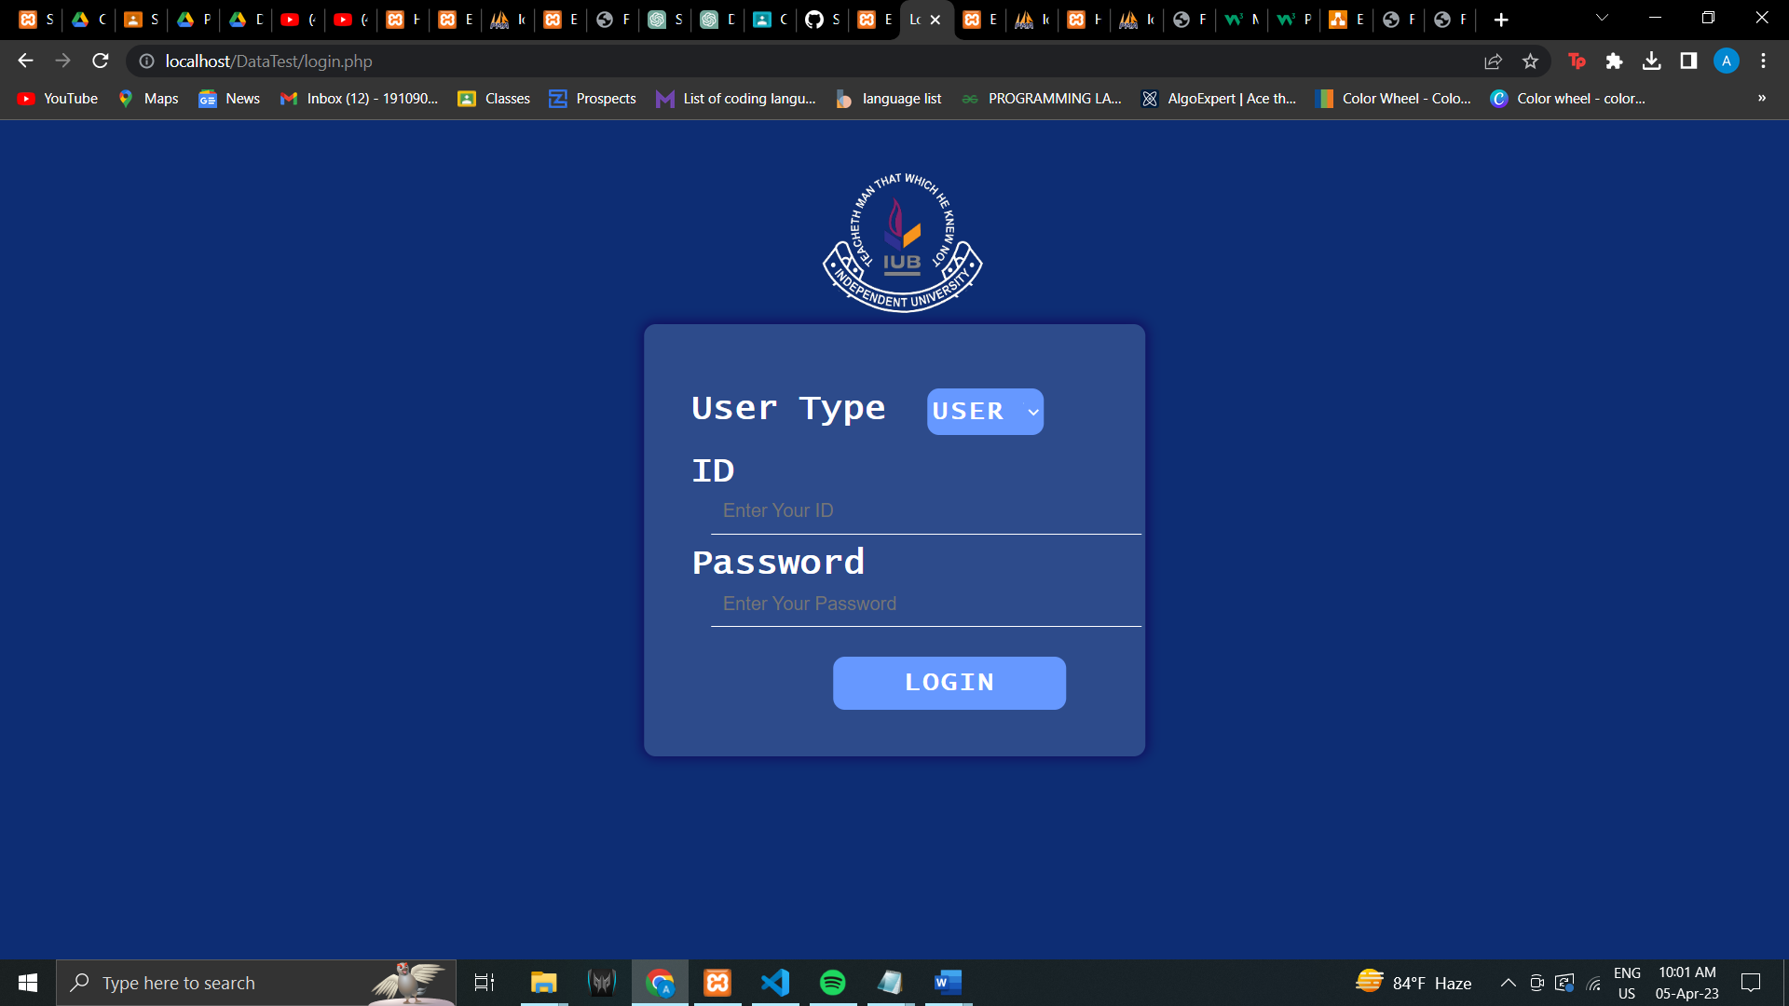

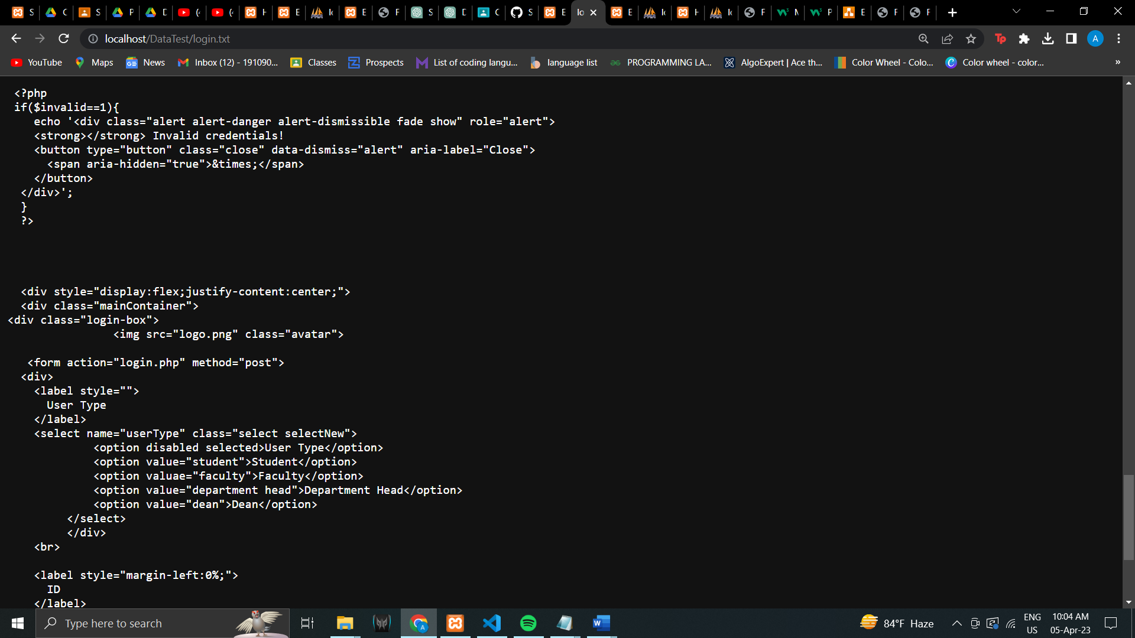

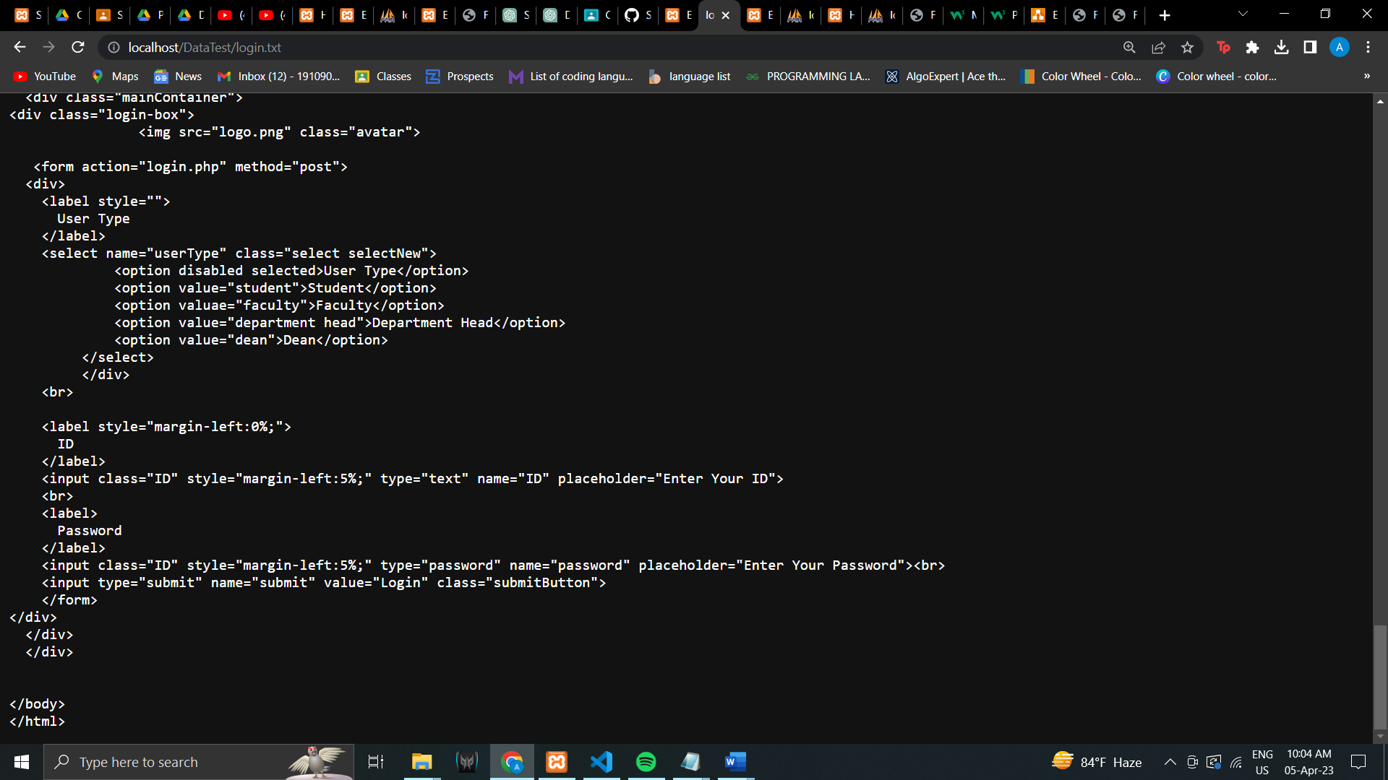

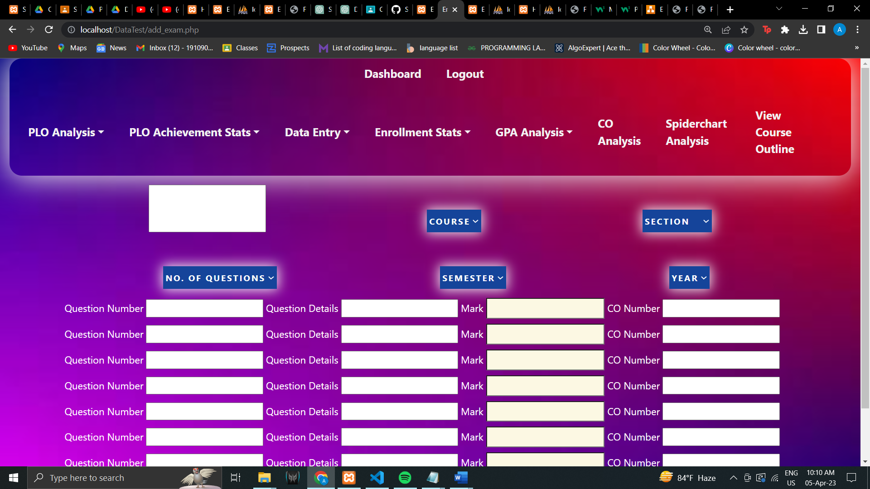

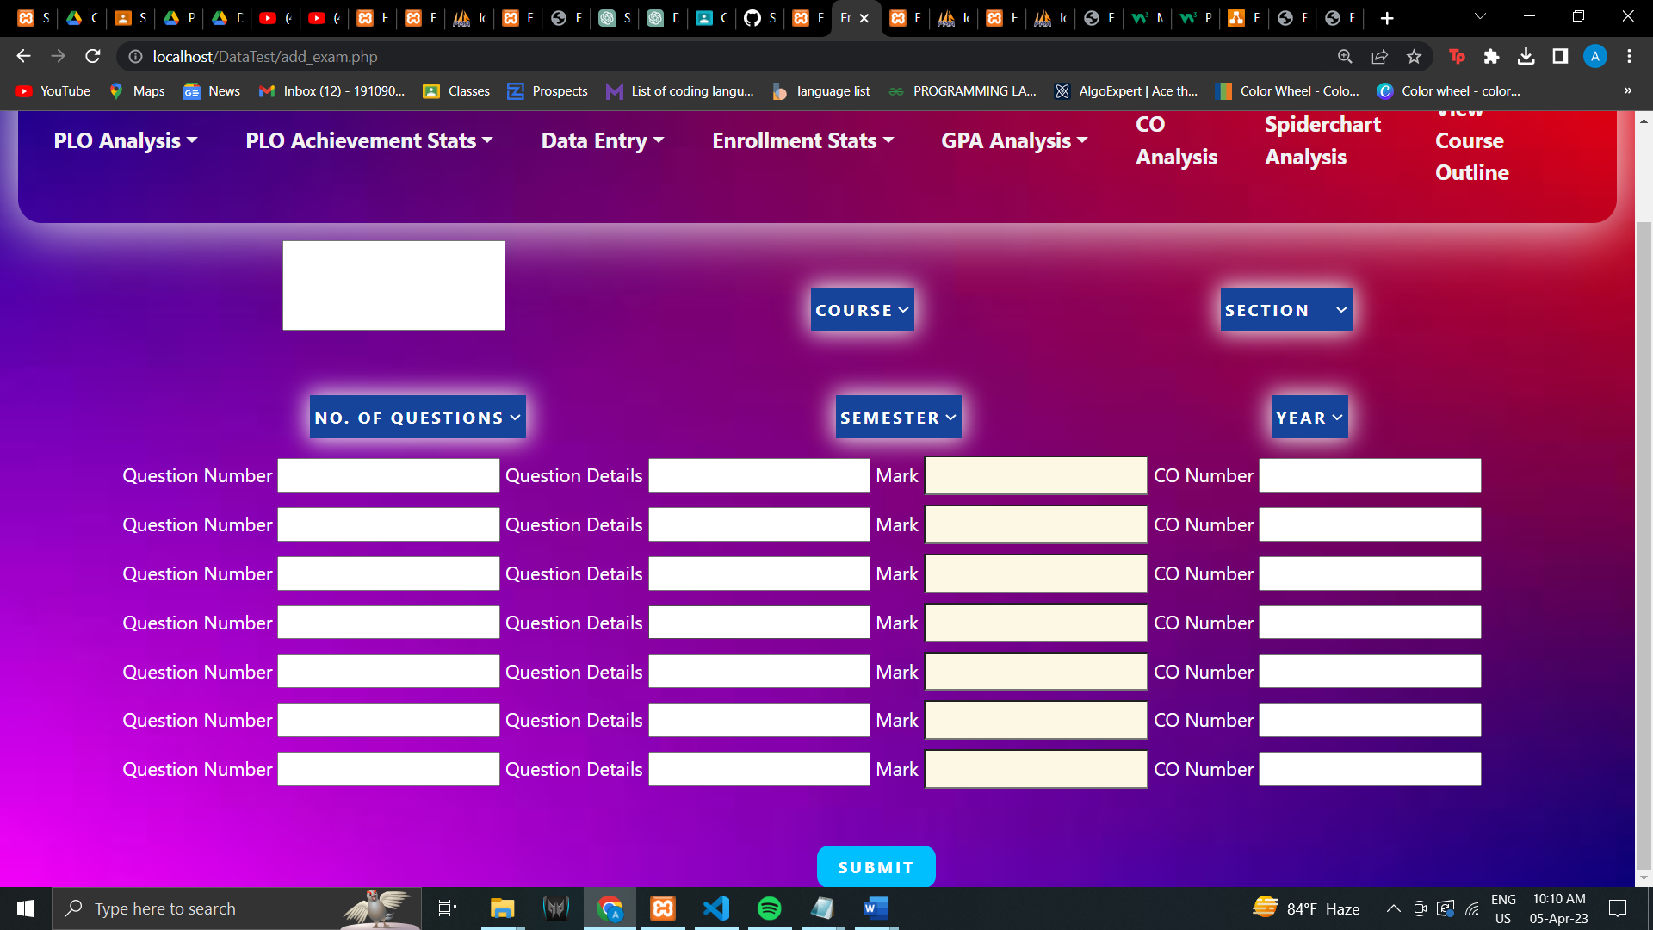

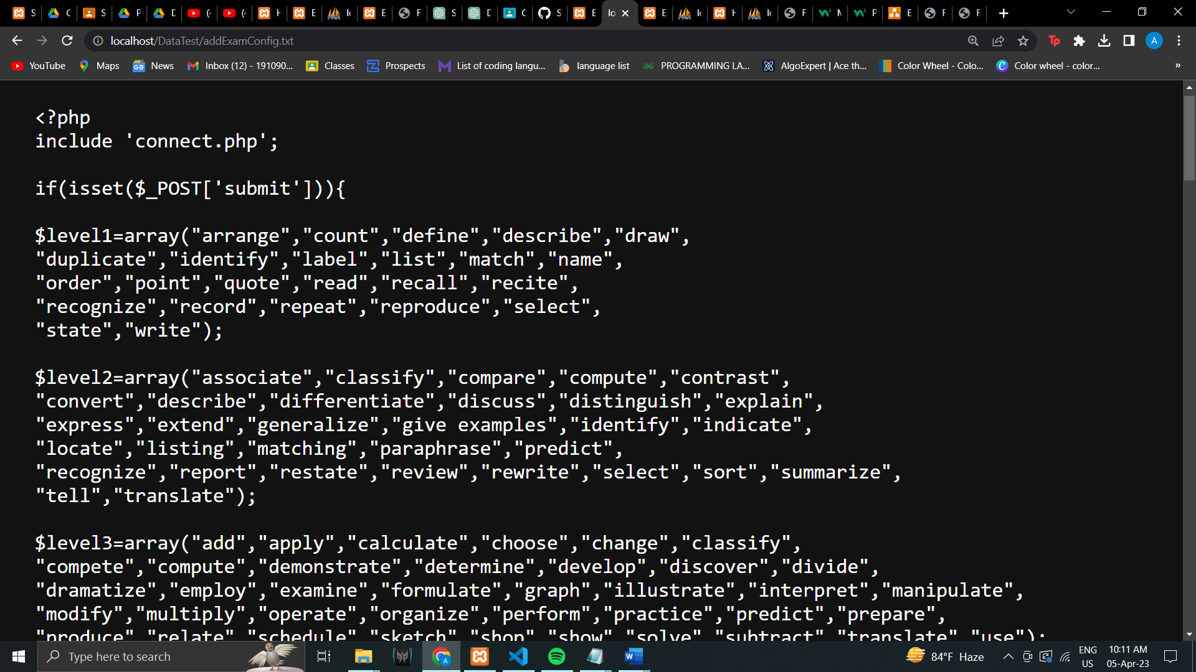

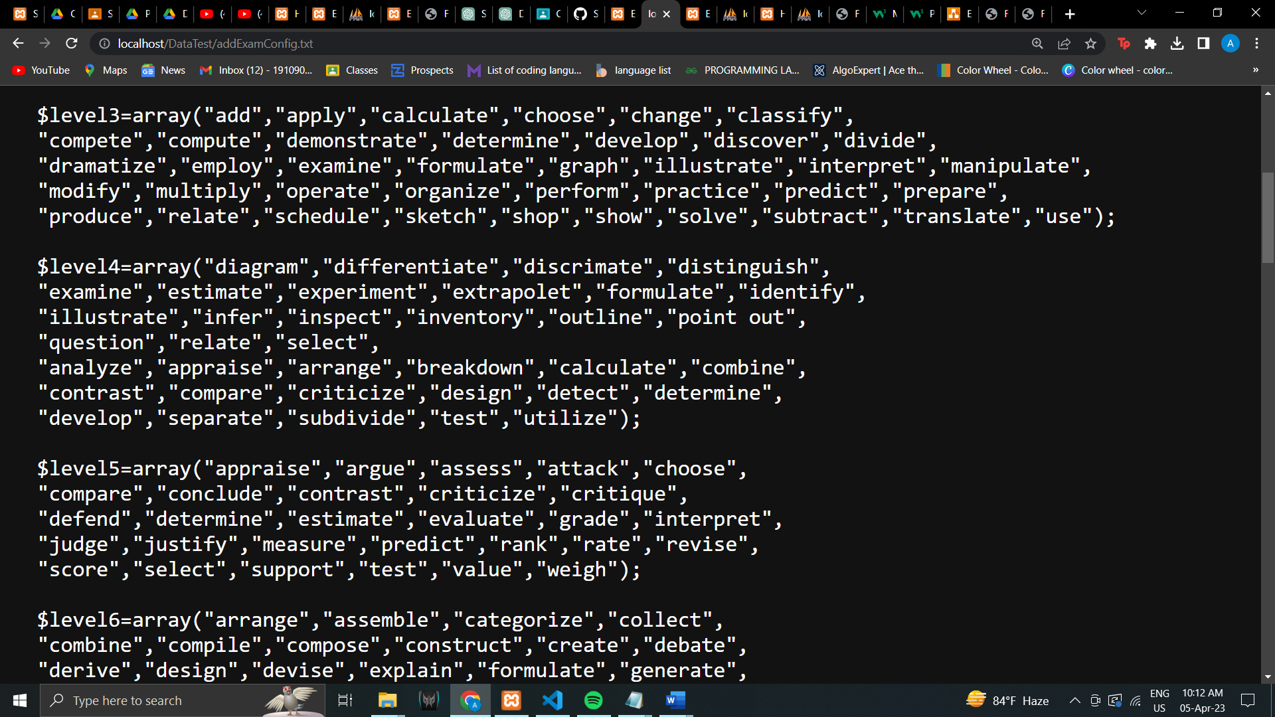

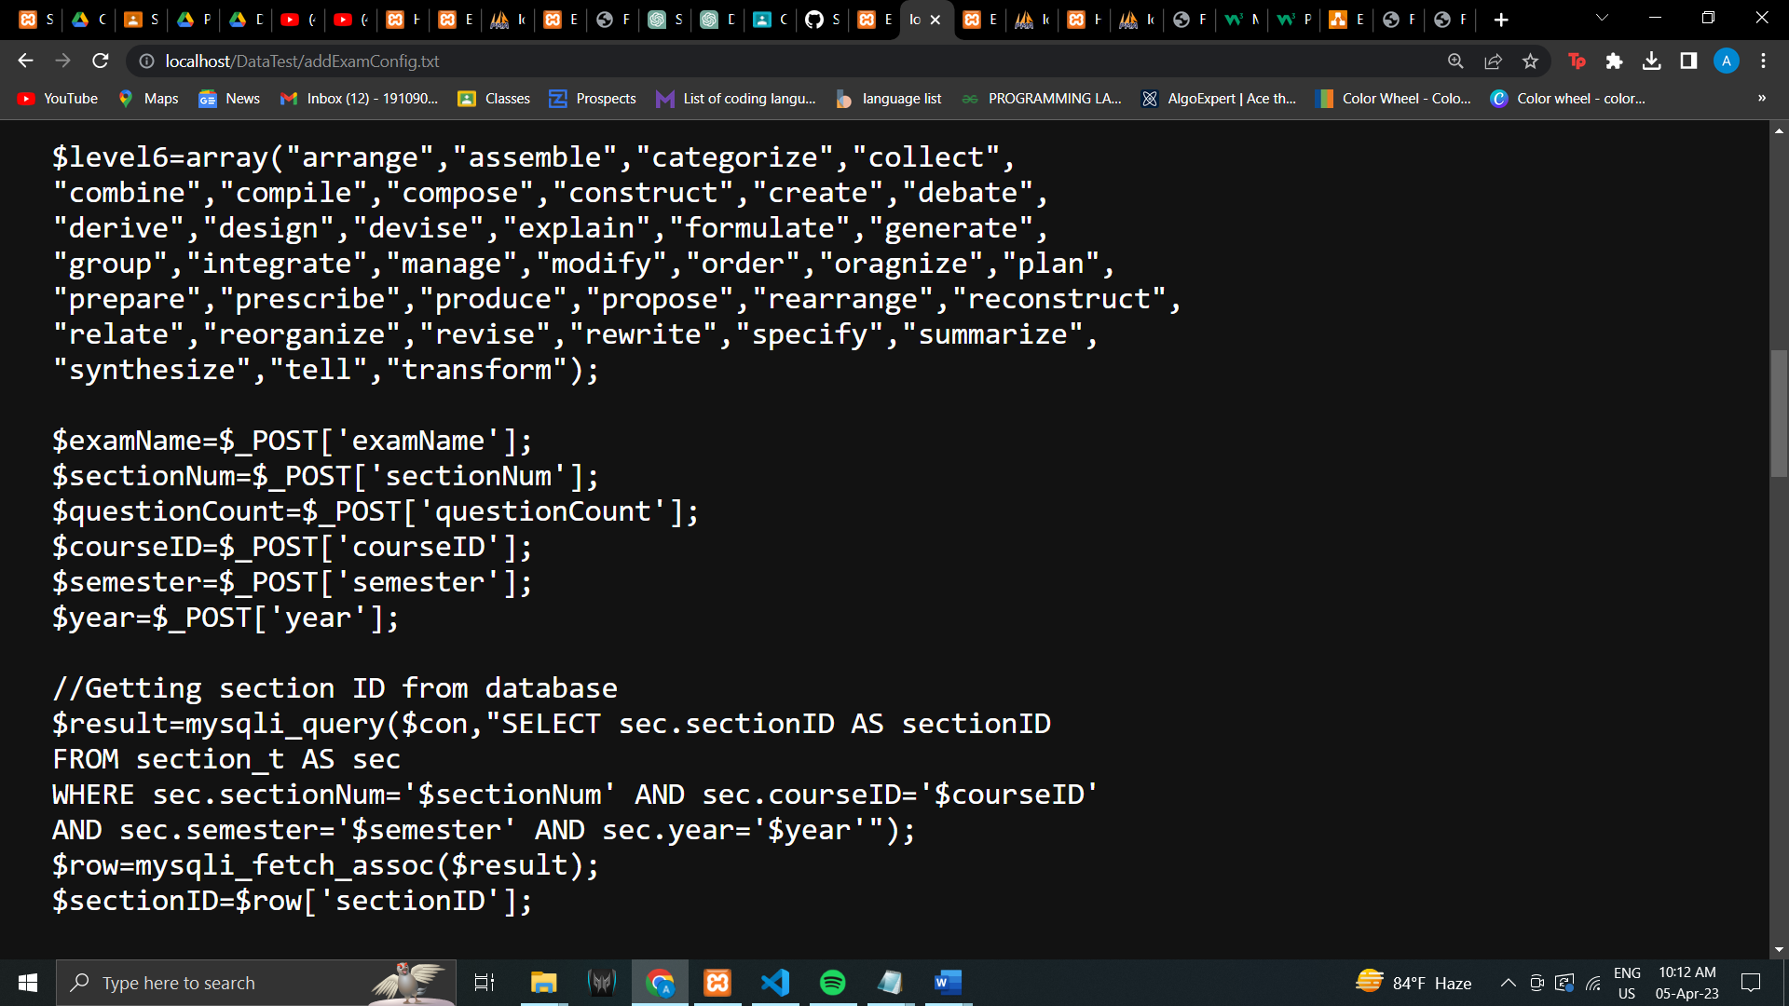

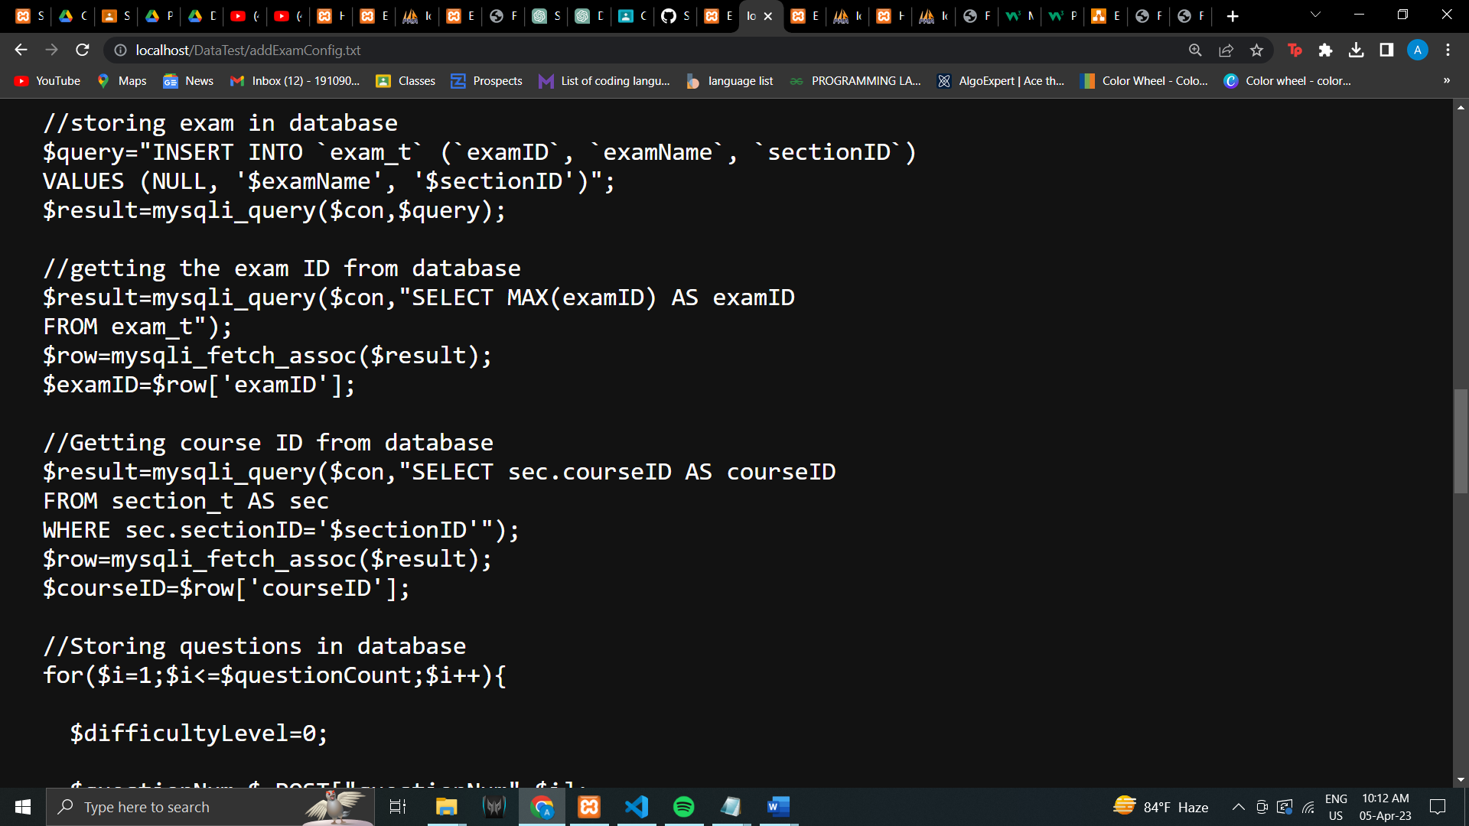

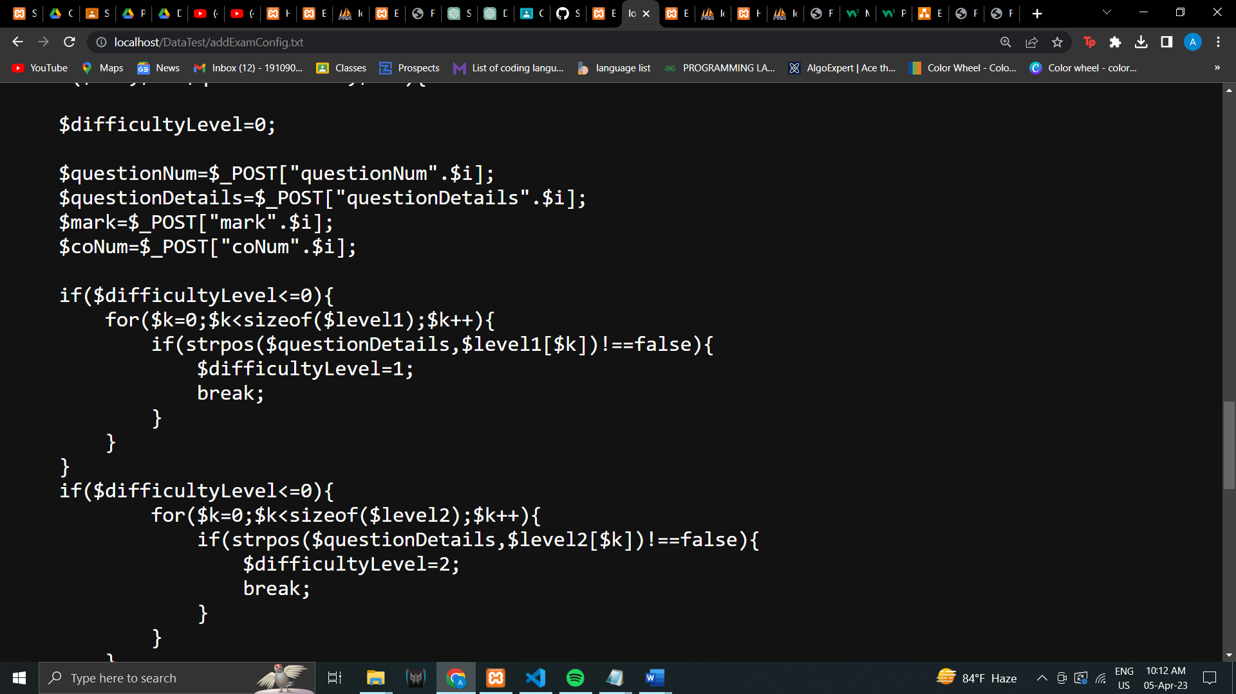

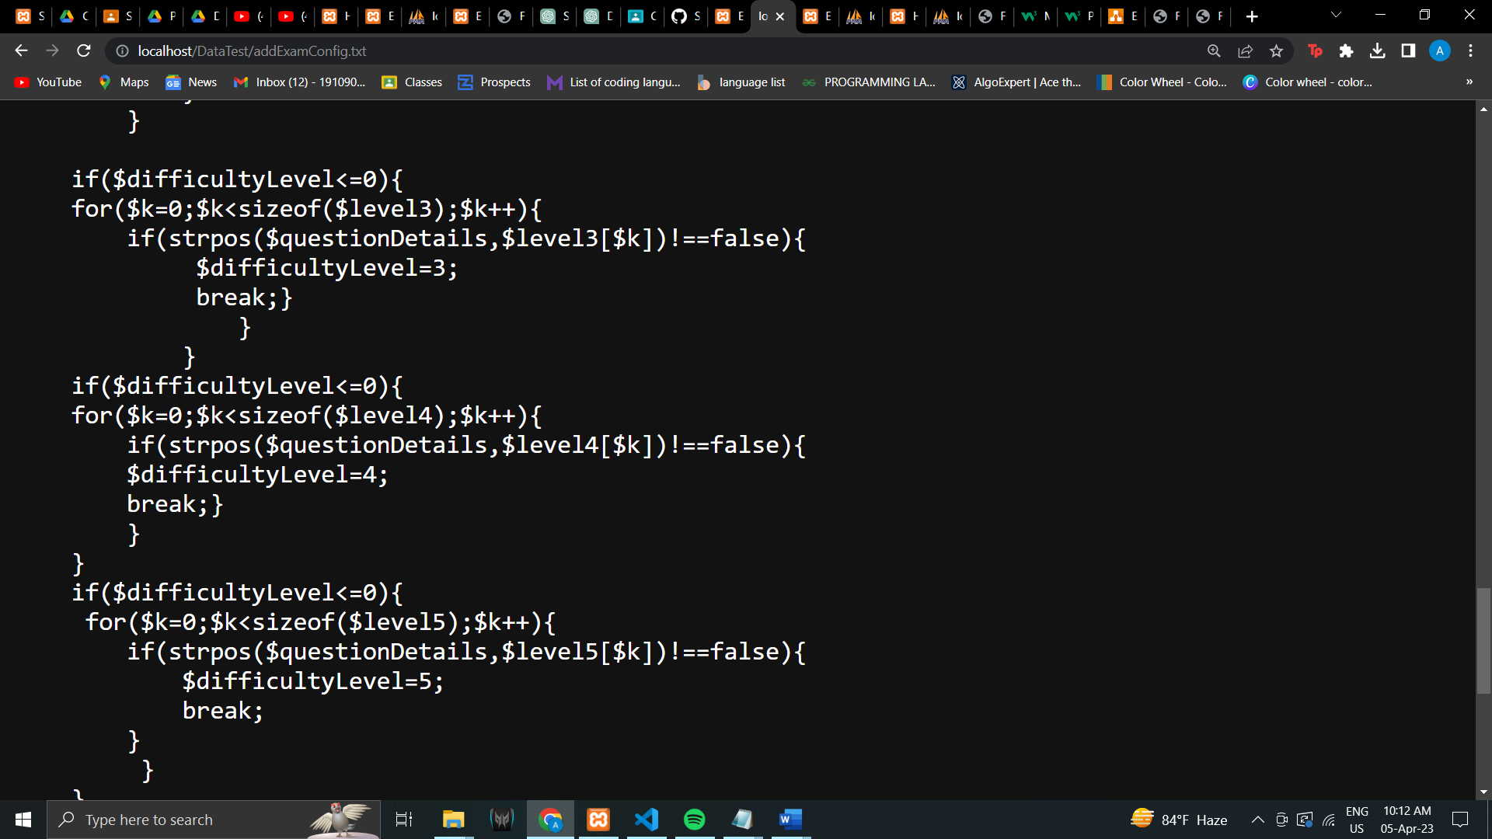

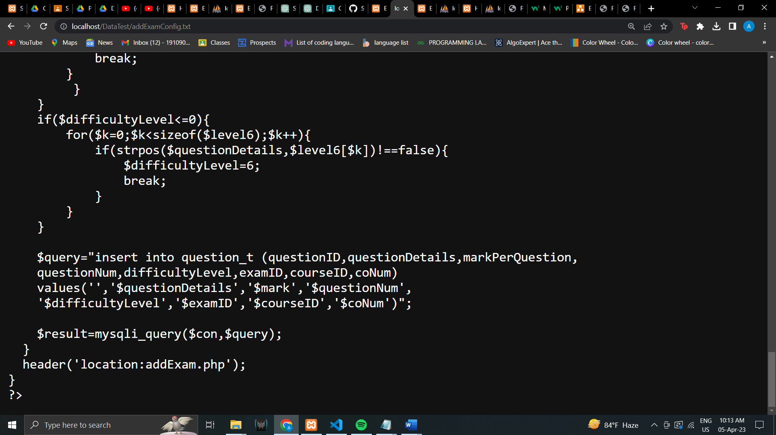

## OUTPUT FORMS:

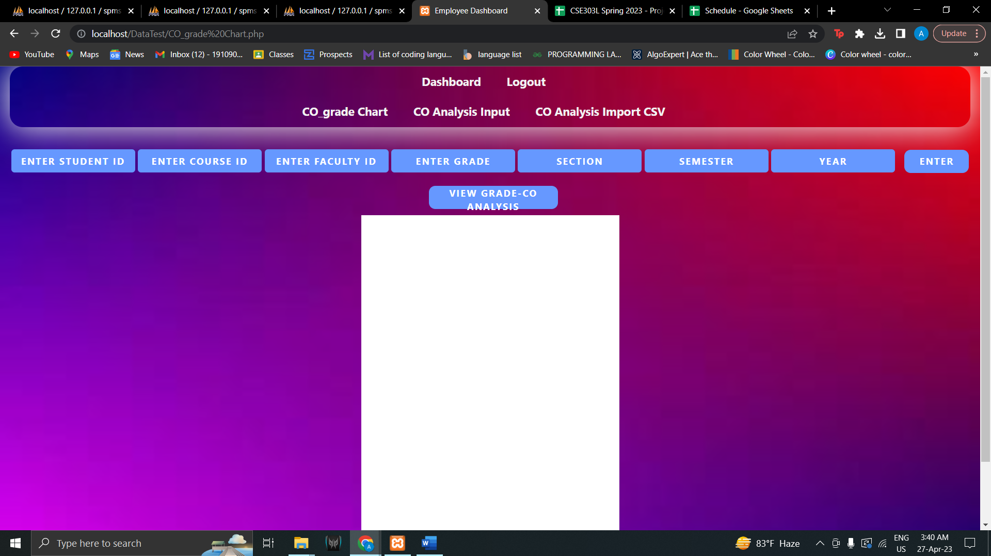

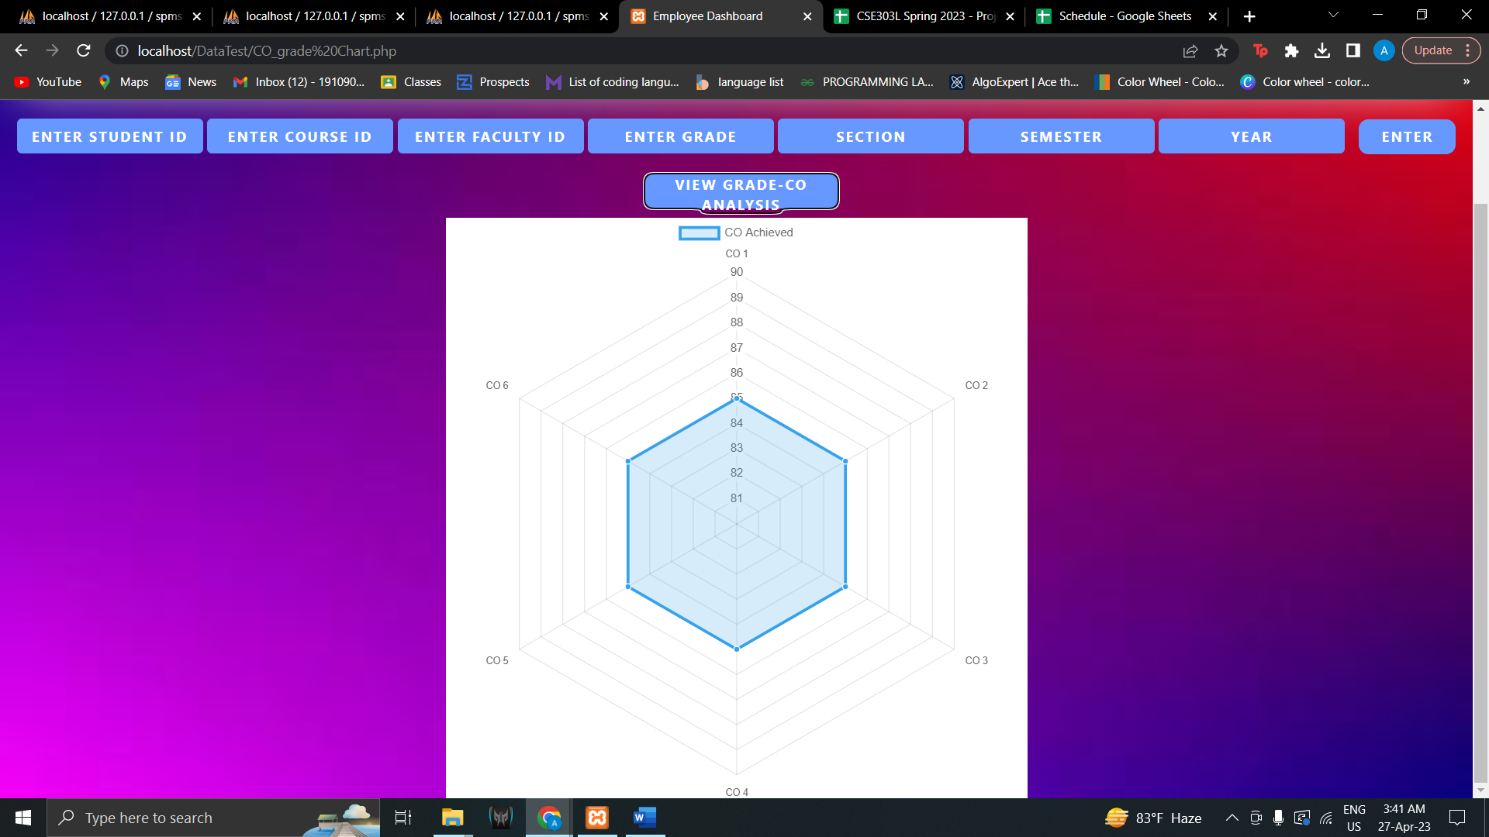

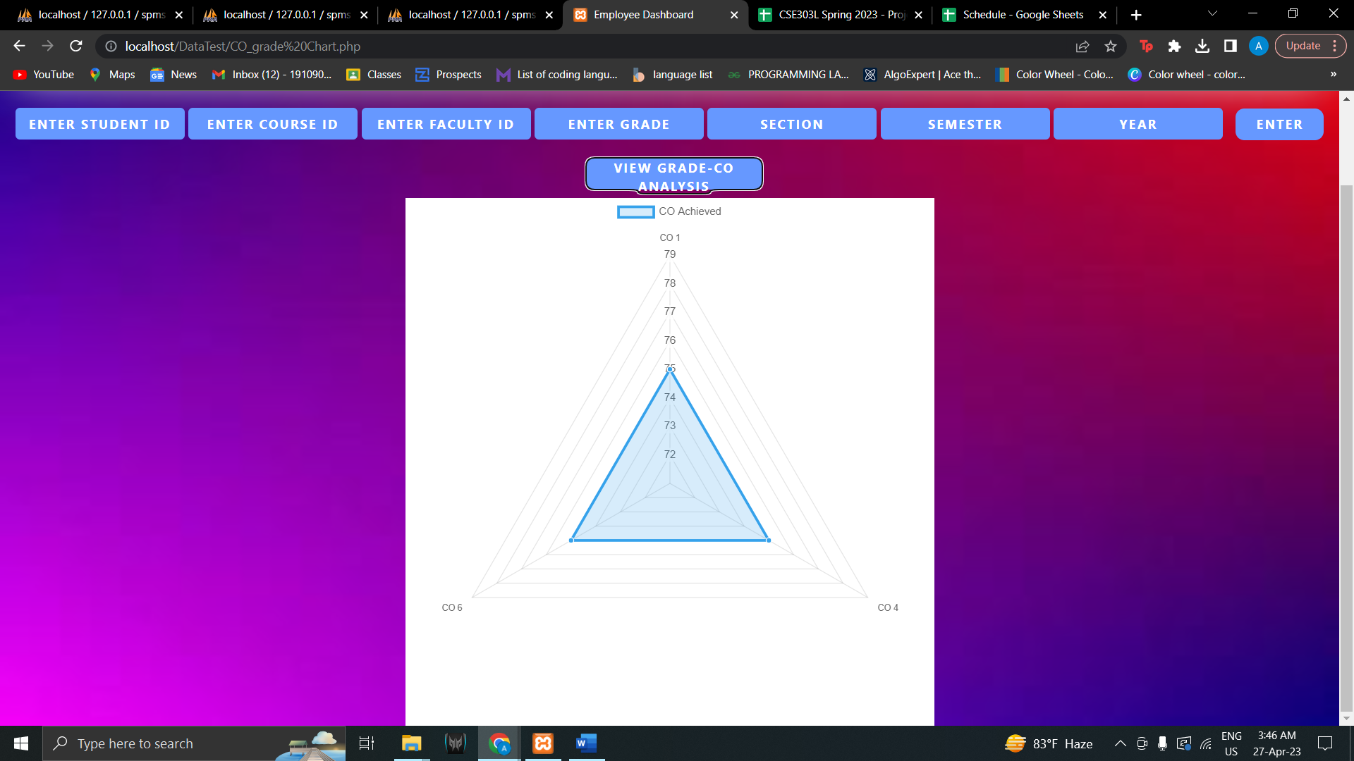

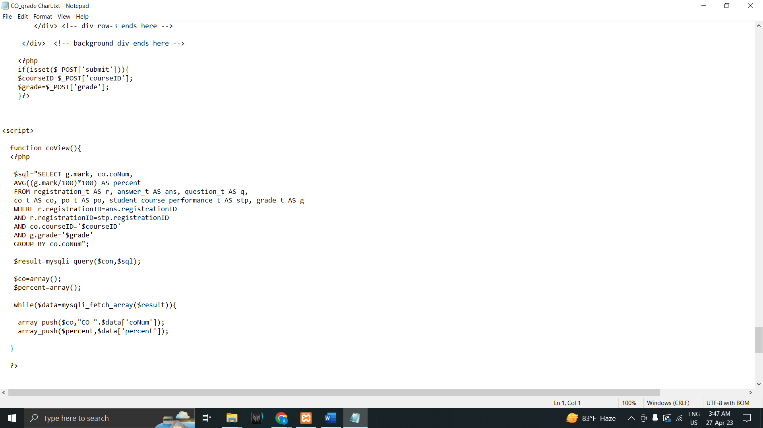

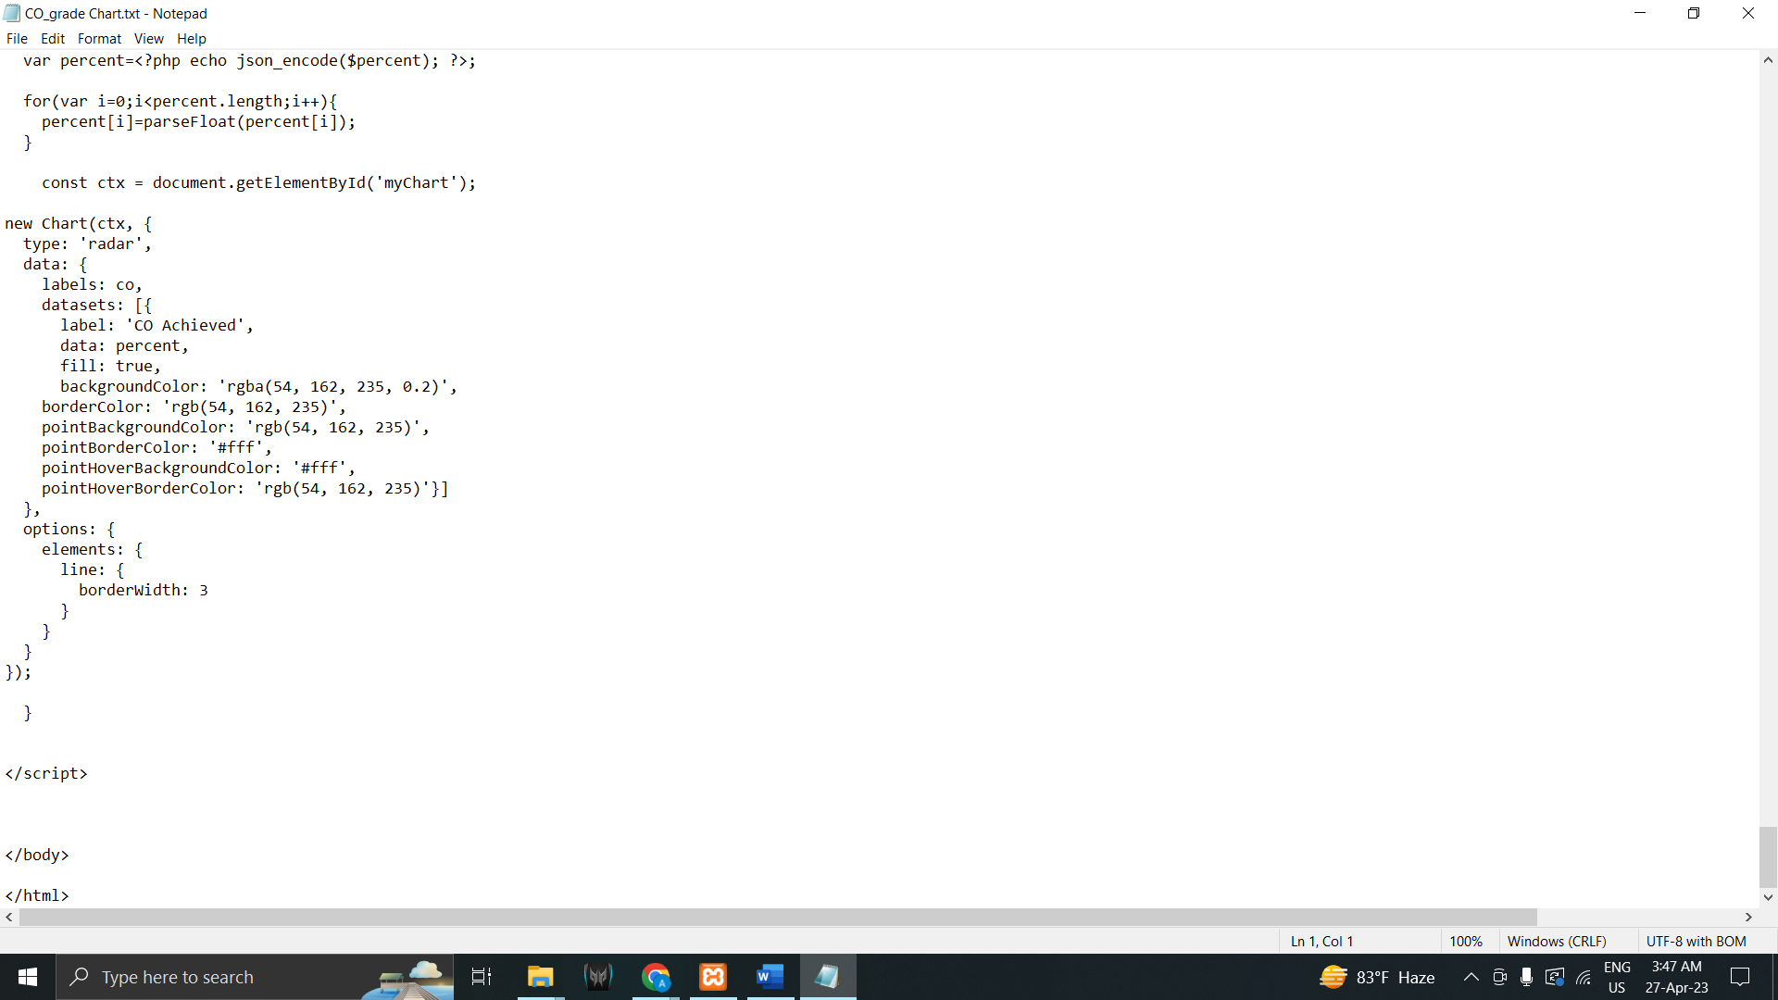

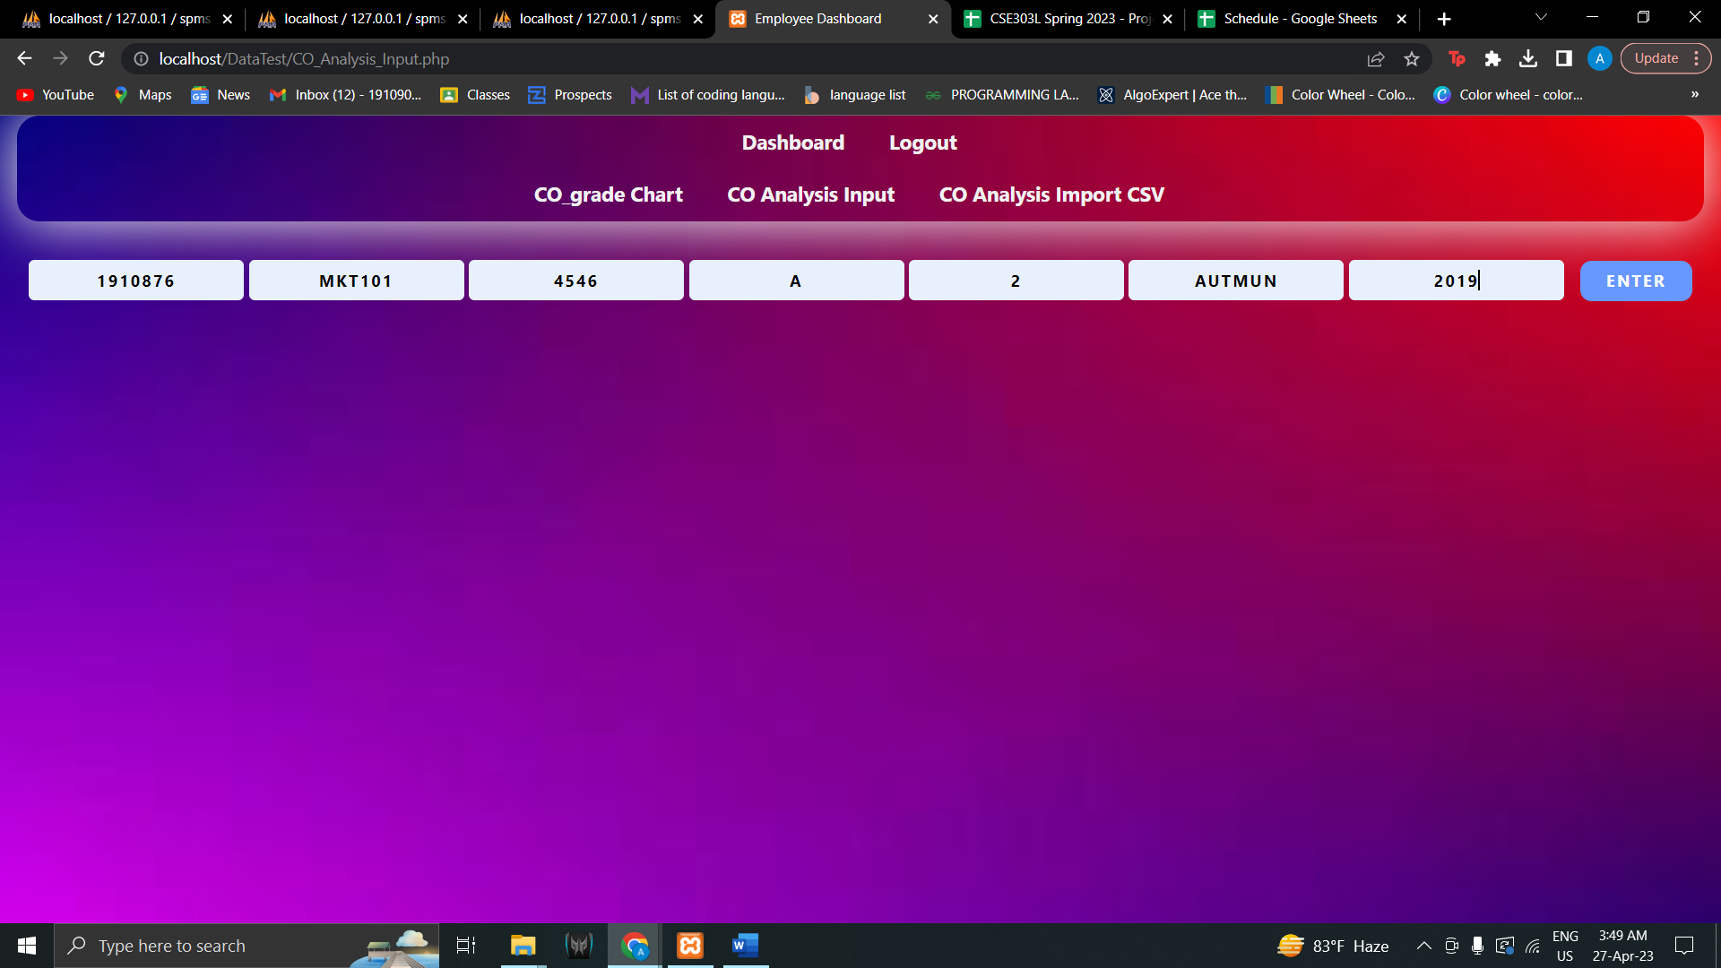

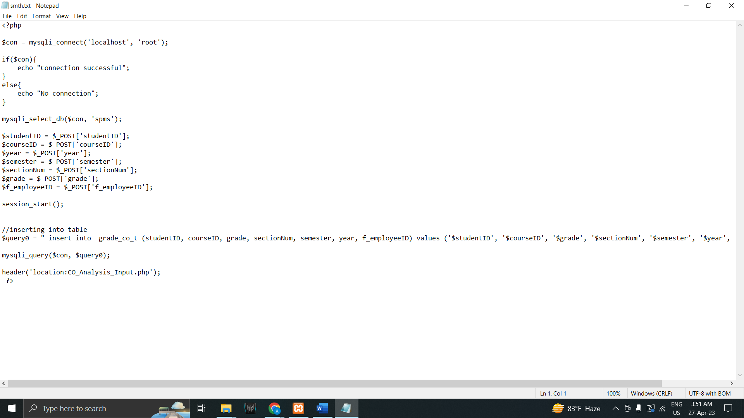

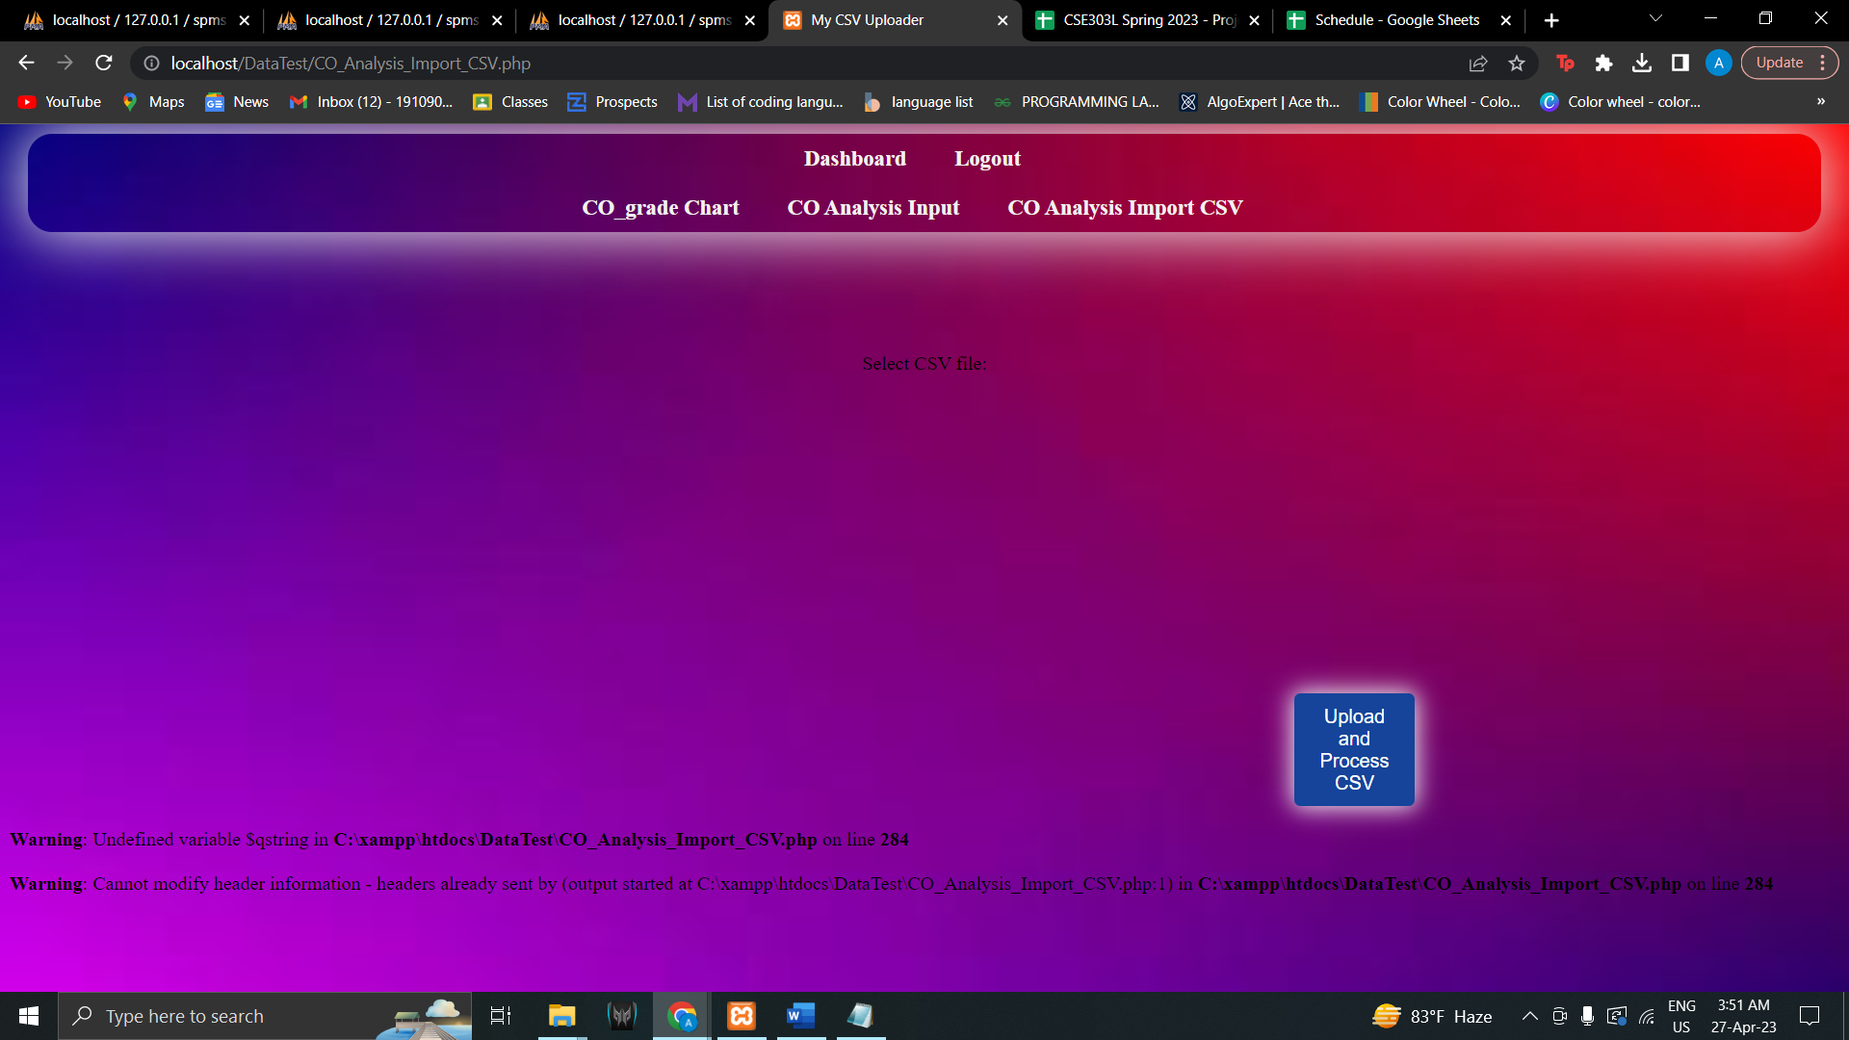

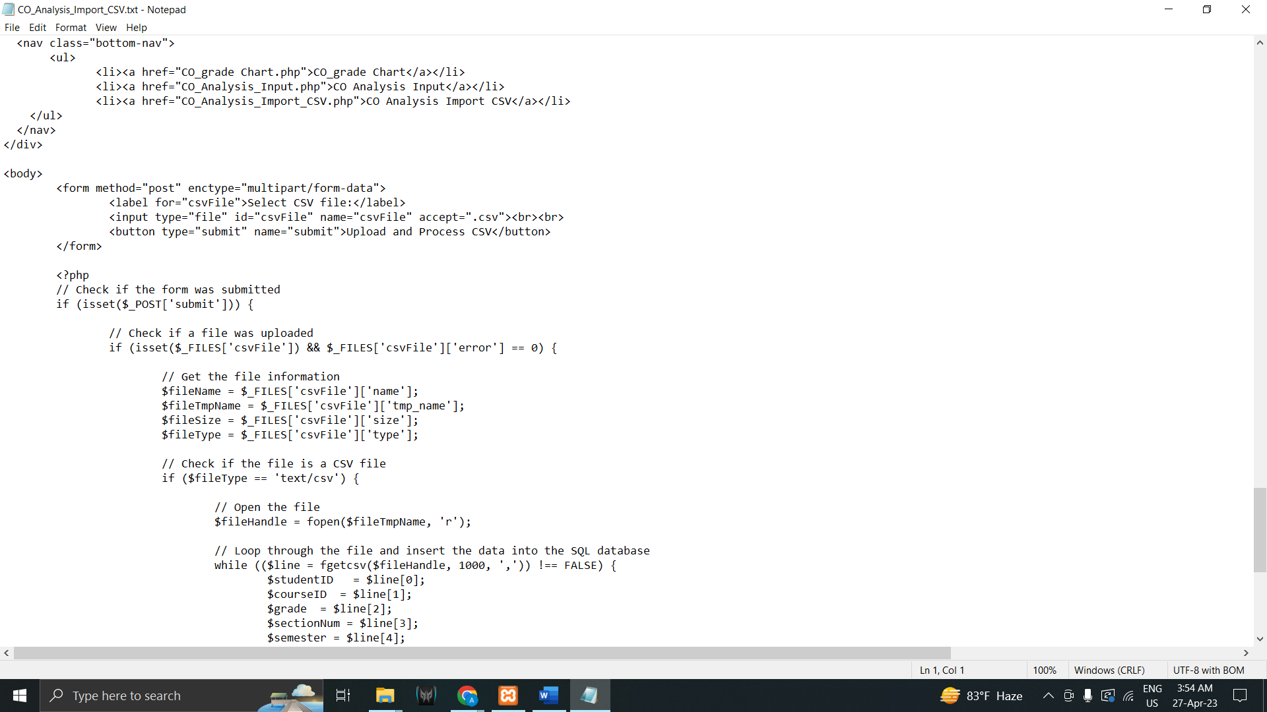

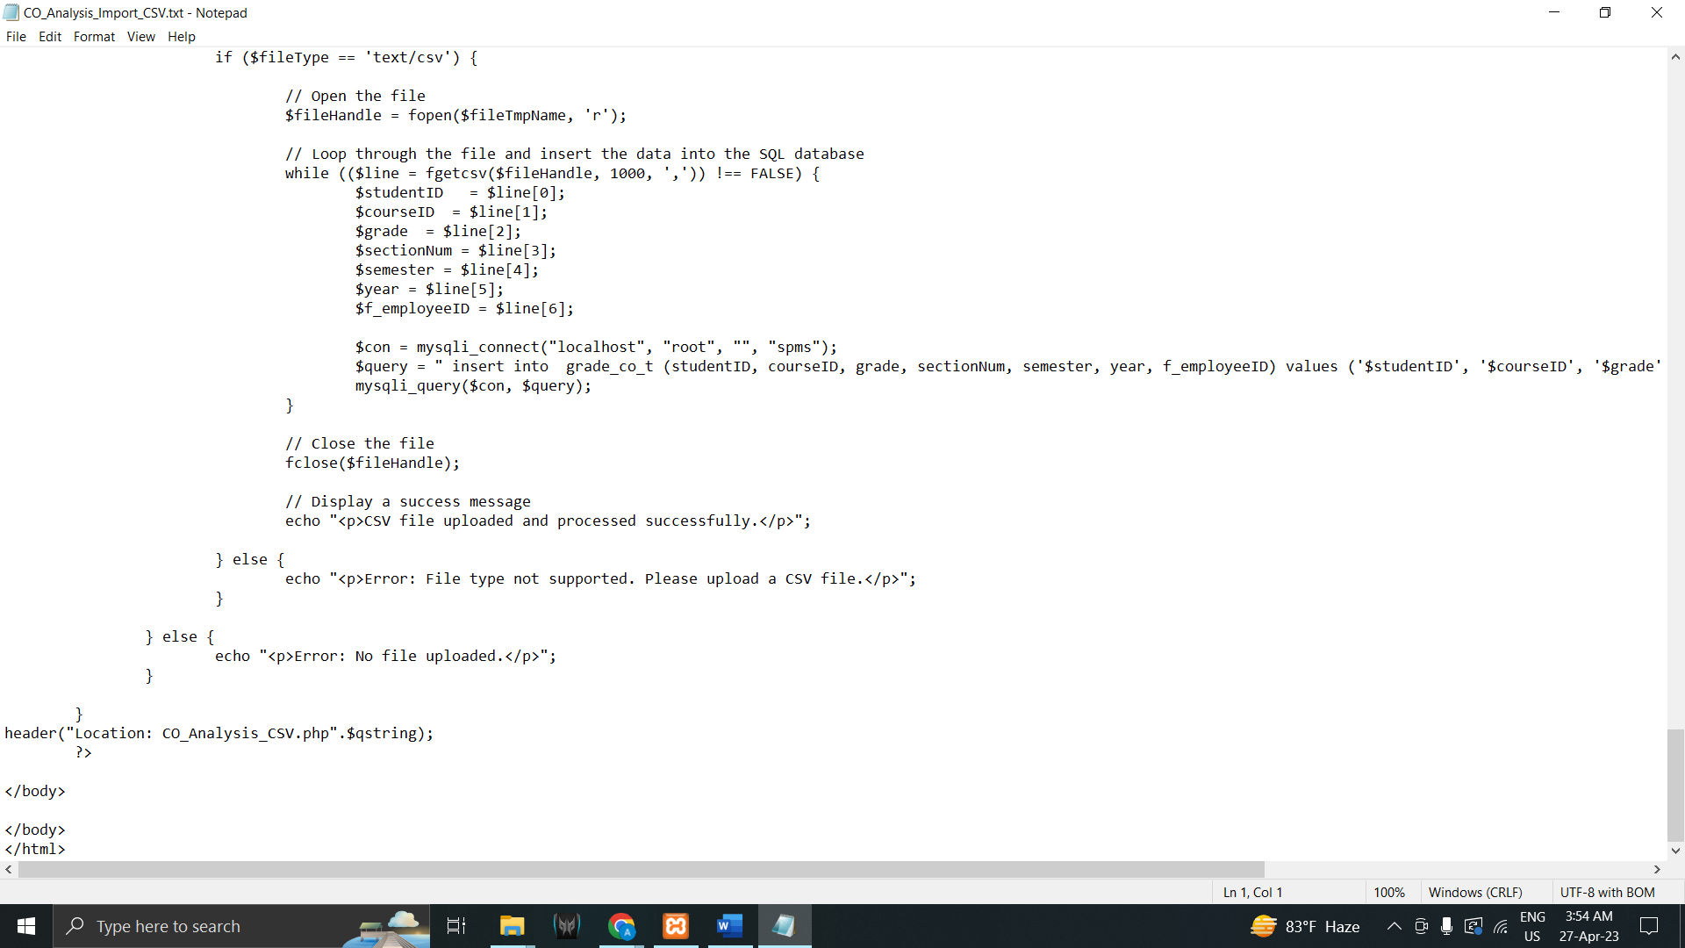

# CHAPTER-5 CONCLUSION

## A.PROBLEM AND SOLUTION:

## Analysis Phase:

During the Analysis Phase, one of the major problems faced was the confusion around the Rich Picture and Six Element Analysis of the organizational operations since there was no data available regarding those operations. However, Faculty members and other stakeholders were interviewed in order to overcome such confusions, and information received during the interview was collected in order to get a better understanding of the system that was being developed.

## Designing Phase:

Some problems were faced while creating the EERD during the Design Phase, However, constant feedback from the faculty were enough to overcome those issues.

## Implementation Phase:

All the System Requirements were completed successfully.

Front-End Developing tools: HTML, CSS, JavaScript, Google Charts, Chart JS Back-End Developing tools: PHP, JSON

Database-integration: MySQL

## Additional Features and Future Development:

One new feature could be added to this system in the near future which can monitor a student’s club and extracurricular activities and then provide reports and analytics based on the student’s extracurricular activity performance.

# References

|  |  |
| --- | --- |
| [1] | [http://www.iub.edu.bd/AboutIUB/ataglance.](http://www.iub.edu.bd/AboutIUB/ataglance) [Online]. |
| [2] | [http://www.cse.iub.edu.bd/degrees/1.](http://www.cse.iub.edu.bd/degrees/1) [Online]. |
| [3] | t. https://mspguide.org/2022/03/18/rich-  picture/#:~:text=What%20is%20a%20Rich%20Picture. [Online]. |
| [4] | b. https://[www.trisotech.com/bpmn-introduction-and-](http://www.trisotech.com/bpmn-introduction-and-)  history/#:~:text=BPMN%20was%20originally%20developed%20by. [Online]. |